
Budbrooke Primary School SEND Information Report
September 2026 – September 2027

Introduction
This document is intended to give you information regarding the ways we ensure we support all of our pupils, including those with SEND, in order that they realise their full potential.
At Budbrooke Primary we recognise that all pupils are individuals and not all pupils are able to access learning in the same way. As a result of this we are committed to providing high quality education for all pupils including those pupils with Special Educational Needs and those with disabilities (SEND). We have strong systems for the early identification of pupils with SEND and always welcome and work in partnership with parents and carers. In our school we have a wide range of skills to ensure all pupils have access to quality first teaching, targeted support and specialist support, when required, which enables us to endeavour to meet the needs of every identified child.
What kinds of special educational need does Budbrooke Primary School make provision for?
At Budbrooke, we are committed to meeting the academic, social, and emotional needs of all our pupils. We ensure all pupils have the opportunity to reach their full potential and make progress within a positive, stimulating and nurturing environment. We believe pupils thrive when all key people in their lives work as a team to secure the very best outcomes.
We are dedicated to working with parents and pupils with SEND, following the SEND Code of Practice relating to Part 3 of the Children and Families Act 2014 and associated regulations, so we can work together to support your child’s learning journey.
While we endeavour to provide quality teaching, which meets the needs of all pupils in the classroom, some pupils find it more difficult to access the curriculum and may need a different approach or level of support. A pupil is considered to have special educational needs if they have a significantly greater difficulty in learning than the majority of pupils of the same age, or if they have a disability, which prevents or hinders them from accessing the educational facilities provided.
Specific Area Focus
A pupil’s Special educational Needs are generally thought of in the following four broad areas of need and support:
- Communication and Interaction

- Social, Emotional and Mental Health
- Cognition and Learning
- Physical and/or Sensory

Communication and Interaction:
- We provide visual timetable in classrooms and individual visual timetables.
- Now and next boards, social stories, sand timers, talking tins, visual cue cards.
- Members of staff have been trained in TACPAC to support communication through music and touch.
- All staff have received Tier 1 Autism training with some Teaching Assistants and staff completing higher levels of training.
- Individual vocabulary interventions are delivered when required
- We ensure our environment has visual support aids and apply visual and kinaesthetic teaching strategies as part of our daily teaching and learning provision.
- We work closely with the Speech and Language Therapy service, Integrated Disability Service (IDS) and Educational Psychologists (EPS) who provide support and strategies to help in school and at home.

Social, Emotional and Mental Health:
- We offer pastoral support check ins for pupils with staff.
- All staff have received Emotion Coaching training
- The SENCO has completed ‘The Solihull Approach’ training and Trauma training
- The SENCO has completed ‘Trauma informed key adults’ training
- Talk about sessions are delivered individually, when required, to develop self-esteem and self-awareness
- Emotional recognition and regulation coaching is provided through strategies such as Starving the Anxiety/Anger Gremlin and the Talk About for Children intervention programs.
- We work closely with the Specialist Teacher Service (STS) and Educational Psychology Service (EPS).
- The SENCO is trained to lead and support the Early Help Assessment process.
- We offer a lunchtime nurture group for those pupils who may need additional emotional support during this unstructured time.
- We have a Mental Health Lead (Mrs Horlor) and a member of staff that it Mental Health First Aid trained (Mrs Jackson)
- An open access to all regulation room is available for those pupils who are experiencing difficulties. This room (Willow) contains resources and a range of sensory stimulus to support pupils.
Cognition and Learning:
- We work closely with the Specialist Teacher Service (STS) and Educational Psychology Service (EPS).
- Lessons are adapted to meet the needs of every pupil whilst maintaining high expectations, staff have received recent training to support this.
- Targeted support is provided for pupils who need extra support through interventions such as Accelerated Reading and Precision Teaching and in class support.
- Pupil’s progress is monitored and discussed half termly with the Headteacher/Deputy Headteacher/SENCO/Class Teachers.
- Class Teachers and the SENCO work with Teaching Assistants to provide additional support where it is felt appropriate.
- We offer a range of interventions designed to help children achieve their maximum potential such as bespoke English, Maths and Phonics interventions that are informed by assessment data.
Physical and/or Sensory:
- We work closely with the Specialist Teaching Service to identify and support those pupils who have significant sensory needs within the learning environment.
- We work closely with Occupational Therapy and Physiotherapy Services, health services and IDS.
- We are able to access specialist equipment from IDS where they feel it is appropriate.
- We offer a range of fine and gross motor skills interventions and follow the NHS intervention program.
- We provide a range of sensory aids to support pupils.
- We provide learning / movement breaks for those pupils who require it

How will the staff at Budbrooke Primary School know if my child needs extra help?
All progress is tracked and monitored against national or school expectations. If concerns are raised about progress, health, safety and well-being of a pupil then the class teacher will initially have an informal discussion with parents and carers and discuss these concerns with the SENDCO who will then add to the early monitoring report. Teachers will be given a range of strategies to apply within the learning environment.
The SENDCO will then follow this up in the appropriate way, meeting with the Class teacher(s) and Specialist Teacher where they are able to discuss any individual concerns and put the graduated response of ‘Assess, Plan, Do Review’ into action through a Pupil Passport that is reviewed termly. We will observe and monitor behaviours and progress. Pupils who we believe need extra support will receive targeted intervention using the graduated response.

Budbrooke Primary School works closely with a number of outside agencies, seeking their advice and guidance where required. These agencies include the Educational Psychology Service, Specialist Teacher Service, Integrated Disability Service, Speech and Language Therapy and Occupational Therapy. The SENCO will discuss any concerns with these professionals to seek further advice and support for your child and may seek permission to refer for further assessment.
What should I do if I think my child may have a special educational need or disability? – please see the guide below
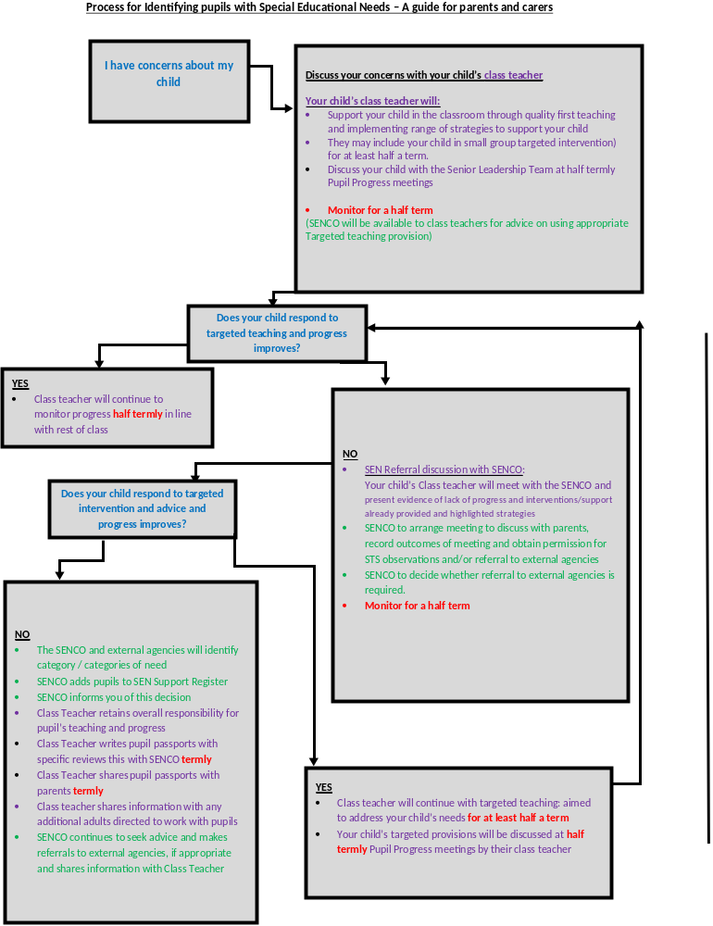

The school works closely with parents in the support of children. We encourage an active partnership through an on-going dialogue with parents. There are instances when parents see concerns at home, which are not always evident at school. We value your contribution to the ‘big picture’ of your child and if you have a concern about your child, it is important that you come and talk to us immediately so we can work together collaboratively.
This can be done by contacting the school office to book an appointment, in the first instance with the Class Teacher, and then if appropriate with the SENDC0.
Maple – Miss Thorpe | Elm – Miss Clapham
Beech – Mrs Lavelle | Holly – Miss Bunney
Chestnut – Mr Brereton | Redwood – Mrs Prestidge
Cherry – Miss Fletcher | SENCO – Mrs Horlor

What kind of support is available at Budbrooke Primary School?
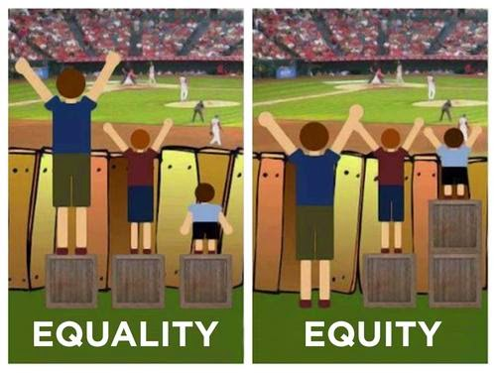
In most cases children’s needs will be met through the class teachers’ adapted and personalised planning and teaching.
As part of the regular assessment process some children will access small group intervention or individual targeted intervention. In some instances, an Individual Education Plan (Pupil Passport) may be created in order to track an individual child’s progress against personalised targets, these targets are formally reviewed termly with your child’s class teacher and shared with parents.
If further advice and support is required, and depending on the area of concern, in consultation with parents/ carers we may decide to refer to a specialist agency.
Examples of intervention
Communication and Interaction | Social, Emotional and Mental Health | Cognition and Learning | Physical and/or sensory
Listening and Memory intervention – games to improve memory skills.  Communication friendly environment  Visual timetables, Now and Next boards, talking tins, timers.  Specific interventions overseen by outside agencies including EPS, Speech and Language Therapy and IDS. | Nurture specific interventions overseen by outside agencies including EPS and STS.  Small group and/or 1:1 intervention sessions  Lunchtime Nurture club for those who need a quieter place to go to at lunchtimes.  Check in pastoral support from key adults.  Emotion recognition intervention/visual cards  Use of the 5 point scale | Nessy – reading and spelling support programme  Accelerated - individual reading intervention  Coloured overlays/reading rulers  Precision Teaching  Handwriting – various intervention strategies including use of kinaesthetic aids for learning  Specific interventions overseen by outside agencies including EPS and STS. | Fine and Gross Motor Skills interventions including MOVES and the NHS physio program.  Specific interventions overseen by outside agencies including Occupational Therapy and IDS.

How are the school’s resources allocated and matched to children’s special educational needs and disabilities?
The SEND budget is managed by the Senior Leadership Team. Resources are allocated on a needs basis and decisions are made based on termly tracking and assessment data. Teachers meet with the SENDCO and STS Specialist Teacher when necessary, to discuss individual concerns and agree next steps.
All parents are invited to attend parents’ evenings which are held twice a year. During these meetings class teachers will discuss how Quality First Teaching is supporting your child.
Where pupils are identified as requiring additional SEND Support, during parents’ evening appointments class teachers will focus their discussions on classroom-based strategies, along with a personalised intervention plan (Pupil Passport) which will give clear targets and interventions. An additional meeting can be arranged with the SENDCO if this is required
Interventions will be reviewed on a half-termly basis. The SENDCO, class teacher and Teaching Assistant will then meet to move these targets forward.

How will you help me to support my child’s learning?
All parents are invited to attend parents’ evenings which are held twice a year. This is an opportunity to discuss your child’s progress with their class teacher who can offer you advice about supporting your child’s learning at home. If your child is on the SEN register you will receive their new targets at this meeting. If you are unable to attend the targets will be sent to you.
In addition to this, the parents of children who hold an Education Health Care Plan (EHCP) will be invited to attend Annual Review meetings where there will be an opportunity to liaise with school staff and outside agencies involved to review your child’s targets and their needs.
Our school website also has a section dedicated to SEN and additional support needs where you can find some useful resources to help to support your child.
Any parent who would like help to support their child’s learning can contact the class teacher or SENDCO for advice and signposting to other sources of support. The Special Educational Needs and Disabilities Information and Advice Service (SENDIAS) is also available to support parents and can be contacted on: 024 7636 6054 or email warwickshire@kids.org.uk
How will Budbrooke Primary School involve my child in decisions regarding their provision?
Children are involved at an appropriate level in setting targets. Pupils on the SEND register are invited to contribute to the termly IEP (Pupil Passport) review meetings.
Intervention plans will be discussed with your child. Pupil views are very important to us, as a child is much more likely to achieve a personal target they have set for themselves than one that has been generated for them.
How will Budbrooke Primary School support my child to access the range of activities available to pupils?
Teachers adapt learning activities so they are accessible to all learners as part of their lesson planning.
Where pupils require specific resources, additional adult support or adaptations to the learning environment this will be documented through the class provision map which is updated in consultation with the Headteacher and the SENDCO each term.
How accessible is the school environment?
School is on single level with disabled pupil toilet and washing facilities available. A classroom environmental audit is completed once a year-more often if necessary, due to advice sought for sensory needs.
What support will there be for my child’s overall well-being?
Your child’s class teacher is at the heart of a well-established pastoral system and will be the first point of contact for pastoral care. We offer regular pastoral ‘check ins’ as well as small group or 1:1 pastoral support with a trained teaching assistant/ Mental Health First Aider or our SENCO. We have a Mental Health Lead and members of staff that are trained Mental health First Aiders.
With parental consent we are able to refer your child to an Educational Psychologist or to the RISE branch of CAMHS, if it is felt appropriate. We can also seek further support from other outside agencies with parental consent such as Connect for Health.
How are staff trained to support my child’s needs?
Budbrooke Primary School is committed to the continued professional development of staff. Five days per year are dedicated to staff training and this provides an opportunity to raise awareness of specific needs and effective support. In addition to this, twilight training sessions are held as required to develop understanding and expertise of specific needs. Recent training includes: Autism Tier 1, Emotion coaching, Every child needs a champion, Writing SMART targets for pupil passports and Restorative conversations
How will the school prepare and support my child when joining Primary School or when transferring to another class, Key Stage or school?
For pupils who are joining reception, an induction period with a staggered introduction is arranged by the Reception team. Home visits are offered and for those children who have already been identified as having additional needs, transition meetings will be arranged involving the parents and outside agencies. There are numerous opportunities to visit and attend school (with and without parental support) throughout the transition period before the beginning of the academic year. Transition meetings are arranged for parents, where information is shared, as the children move through Key Stages.
Transition meetings will be arranged for children leaving year 6 with the Secondary schools where the teacher and SENCO will share relevant information to support this move this may be with the SENCO or the Year leader.
Transition within school is carefully planned and managed with a transition day and a transition booklet that is sent home. The transition booklet contains photographs of any adults that the pupils will be working with and their new learning environment, including cloakroom areas and playgrounds. An opportunity for parents to meet new members of staff is also provided on the transition day that takes place before the new academic year. During this time new class teachers identify key information and this is then made available on the school website (under the transition tab) so that all pupils and parents can access this.
What do I do if I’m not happy with the provision being made for my child?
We encourage parents to be part of their children’s learning journey and therefore if you may have any concerns we would encourage you to contact the class teachers in the first instance. Alternatively, you may wish to book an appointment with the SENCO or Headteacher. This can be done by contacting the school office to book an appointment.
More information can be found in the complaints policy: School information / Policies/ Trust Policies
https://www.communityacademiestrust.org/about-us/trust-information

Who can I contact for further information?
In the first instance please contact your child’s class teacher, they are available to speak to when you drop off or collect your child. Alternatively, please make an appointment to see them via our school office.
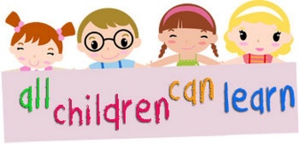
SENCO – Mrs Horlor Email: sen2033@welearn365.com
Headteacher – Mrs N Horlor
Office - admin2033@welearn.com
Where can I find out about the support available for pupils with SEND within Warwickshire?
The Warwickshire LA Local Offer can be located at http://www.warwickshire.gov.uk/send

