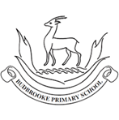
Maths
Place Value
Partition numbers to 100 and write numbers to 100 in words.
Addition and Subtraction
Add and subtract across a ten.
Subtract a 1-digit number from a 2-digit number.
Add and subtract two 2-digit numbers.
Solve problems of addition and subtraction.
Shape
Count sides, vertices on 2D shapes.
Identify lines of symmetry on shapes.
Count edges, faces and vertices on 3D shapes.
English
Our class text is ‘Claude in the City’ by Alex T. Smith, a humorous adventure following Claude, a curious little dog, and his best friend Sir Bobblysock as they explore the city and find themselves in some unexpected situations. We will write a variety of fiction genres with a focus on adjectives, verbs and conjunctions to make our writing more interesting. We will also develop our accuracy when using capital letters, full stops, question marks and exclamation marks, while exploring different sentence types.

Curriculum Newsletter
Year 2 -Beech
Autumn Term

Other Information
PE days: Monday and Wednesday. Children will need their PE kits in school at all times.
Class visit: The Tower of London - Thursday 22nd October 2026.
Theme: The United Kingdom

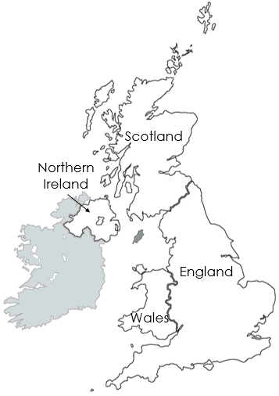

This project teaches children about the United Kingdom, including its four countries, capital cities and surrounding seas. Children will use maps to locate places and explore the human and physical features found across the UK.
Geography – The United Kingdom
Name and locate the four countries of the United Kingdom, the capitals and the surrounding seas.
We will identify key characteristics of England, Scotland, Wales and Northern Ireland by understanding more about human and phu.
RE – Special Places
Explore different ways of expressing identity and belonging.
Recount different ways of expressing identity and belonging in Christianity, Islam and Judaism.
PSHE – Health and Resilience
Describe a wider range of feelings and how they
change; use simple strategies to manage them;
know when and how to seek support.
PE – Fundamental Skills
Fundamental movement skills are like the building blocks of all the fun things your body can do. They're special moves that help you play, explore, and stay active.
Ball Skills
This unit develops children’s ball skills, coordination and control through using their hands, feet and eyes together. Children will practise a range of skills that can be applied to different games and sports.
Science – Living Things
This project teaches children about living things and what they need to survive. We will explore the stages of human development, learn about the importance of a balanced diet and investigate simple food chains. Children will also develop their scientific skills by observing, sorting and grouping living things
Art – Wax Resist Nature
This project teaches children to become curious explorers, using our local environment as inspiration for art. We will collect natural objects, experiment with observational drawing, line, shape and mark making, and use a range of materials to create our own artwork.
Computing – Creating Pictures and Making Music
Pupils will use software to create artwork in Impressionist and Pointillist styles. They will experiment with creating their own music.
Music – Folksongs
This project teaches children about folk music from around the world and how it is used to tell stories and bring communities together. We will explore the different instruments, rhythms and traditions found in folk music and how songs have been passed down through generations.

