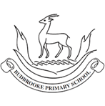
Maths
- Children will represent and partition numbers to 1000 and 10,000 and find 1, 10, 100 and 1000 more or less.
- They will compare and order numbers to 10,000 and round to the nearest 10, 100 and 1000.
- They will add and subtract 1, 10, 100 and 1000 as well as adding and subtracting two 4 digit numbers with exchanges.
- They will compare the area of shapes and multiply and divide using the 6, 7 and 9 times table.

English
Children will write a narrative recount based on The Pebble in My Pocket They will also write free verse poems about the journey of the pebble using noun phrases to describe the settings. They will also write persuasive letters and an explanation piece about the water cycle.
In Guided Reading, children will explore vocabulary from The Pebble in My Pocket as well as developing their inference, prediction, explanation and summarising skills.

Curriculum Newsletter
Year 4 -Chestnut
Autumn Term

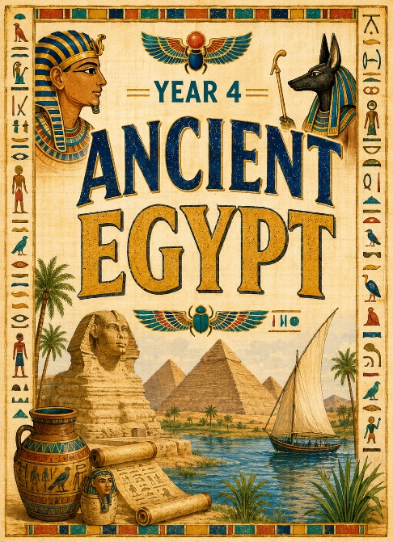
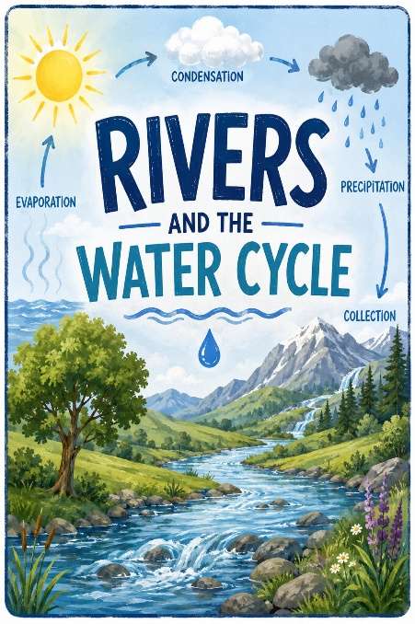
Geography – Rivers and the Water Cycle
Children will be able to describe and understand key aspects of physical geography, including rivers and the water cycle. They will be able to locate rivers locally and around the world, identify the different stages of the river and the river features.

History- Ancient Egypt
Children will be able to explain the importance of the River Nile. They will explore the significance of the Rosetta Stone and how deciphering hieroglyphics has helped historians understand Ancient Egypt, as well as describe Howard Carter’s discovery of Tutankhamun’s tomb. Children will research Egyptian society, and explain the significance of the pyramids and how beliefs about the afterlife led to the development of mummification and the preservation of the dead.
RE – Hinduism
Children will learn about what it is like living as a Hindu, Gods, Goddesses and their stories and festivals and Brahman, The Trimurti and Creation stories
PSHE – Health and Resilience
Children will explore managing big feelings, develop resilience strategies and recognising when to seek help. They will understand what is a balanced lifestyle, the impact of poor diet, lack of exercise, poor sleep and how habits affect health.

PE – Dance, Fundamentals and Ball Skills
Children will use the key features of dance such as actions, dynamics, space, relationships, balance and jumping. They will also focus on balancing, running, dodging, hopping and skipping. Ball skills will focus on developing tracking, throwing, catching, dribbling and kicking.
MFL- La Fonetica, Presenting Myself, Healthy Lifestyle
Children will develop their ability to communicate in basic Spanish by using greetings, asking and answering questions about how they feel, their name, age and where they live. They will recall numbers 1–10 and count from 11–20, while also learning to express their nationality and develop an understanding of basic gender agreement rules.
Science –
Food and Digestive System
Children will identify teeth types and their functions. They will link this learning to animals' diets and construct food chains to show the flow of energy.

Sound
Children will find out about sound, how sound is made and how sound travels as vibrations through a medium to the ear. They will learn about pitch and volume and find out how both can be changed.

Art – Drawing & Sketchbooks/ Print, Colour & Collage
Children will use line, shape and colour to create patterns, use folding, cutting and collage to enhance their patterns and create repeated patterns to apply to a range of products and outcomes.
Computing –Animation, Unpacking Hardware and Software, Sound Stories. Children will understand what animation is, learn and apply onion skinning techniques for 2D computer animation, enhance simple animations using software, plan and create narratives through animation. They will learn how tech is used in everyday life, and how it supports us at school, at home and beyond. They will identify and describe different computer hardware and their functions, understand what software is and how it helps us complete tasks. Children will also understand what makes audiobooks effective and engaging, develop and write an engaging script, record clear narration with suitable sound effects, and use recording and sound-design tools to edit, improve and finalise the audiobook.
Music – Rivers and Jazz
Children will listen to and identify instruments, compose music using the graphic score and pentatonic scale, perform melodies using graphic notation and singing in unison as well as using pitch and rhythm using the key features of jazz.
Other Information
PE days: Wednesday and Thursday. Children will need to wear their PE kits in to school on these days.
New homework and spellings are given out on Thursdays and are to be handed in by the following Tuesday.
Trip – Hams Hall Environmental Centre- 1st October 2026.
Children will explore the River Tame and find out about river systems with hands-on experiments and activities investigating the river’s properties and the habitats it provides for wonderful wetland wildlife.

