
English
We will begin our book study of ‘The Promise’ which links to our Sustainability topic. In the second part of the term, we will study the novel ‘Street Child’ which links to our Crime and Punishment theme. The children will write in a variety of genres including a poem, a persuasive letter and a narrative story. We will continue to expand and develop our knowledge of vocabulary and use of punctuation and grammar.

Maths
This term, we will be reading, writing and understanding numbers up to 10,000,000. We will then move on to calculating with the four operations (addition, subtraction, multiplication and division), understanding square, cube and prime numbers, the correct order of operations and finding common factors and multiples.
In the second half of the term, we will be focussing on fractions and will cover equivalent and simplified fractions as well as calculating with fractions. We will also be finding fractions of amounts and finding the whole from a given fraction.

Curriculum Newsletter
Year 6 - Cherry
Autumn Term

History
This term, Year 6 will explore how crime and punishment have changed in Britain over time Children will investigate strange laws, harsh punishments, prisons, policing and the development of our modern justice system.
Geography
We will learn about sustainability, the distribution of natural resources, food wastage, the threat to biomes and habitats and how we can improve sustainability.
RE
We will begin by exploring our own belief systems and values before moving on to exploring the Creation stories in Judaism and Christianity. We will also learn about Humanism.
PSHE
Our topic this term is ‘Health and Resilience’. We will be learning about balanced routines for health. In our second topic ‘Relationships and Respect’ we will learn about challenging discrimination and stereotypes.
PE
The children will develop their dance skills and netball skills including playing by adhering to the rules of the game. After half term, we will develop Outdoor Adventurous Activities skills through team building and problem -solving activities.
MfL
In our ‘Around Town’ topic, we will develop our listening and speaking skills when describing places in our town and when giving directions in Spanish.
We will also learn vocabulary linked to the Planets.
Science
Pupils will build on their understanding of living things by exploring how and why animals and plants are classified. We will also learn about micro-organisms and group them by their similarities and differences.
We will continue our study of living things by learning about the human circulatory system.
Art
In this project, we will research different types of food packaging. We will design 2D food packaging then move to making 3D food packaging. After half term, the children will explore activism through the topic Print, Colour and Collage.
Design Technology

This project will help us to learn about how cams create movement. We will research, design, make and evaluate a simple toy that uses a cam.
Computing
We will explore the purpose of blogs. We will explore the reviewing and commenting on blog posts with an understanding of online safety before moving on to create our own blogs. After half term, the children will learn about networks.
Music

In our ‘Arctic’ topic, we will use graphic notation, compose a melody, explore dissonance and consonance and listen to and appraise the performances of others. After half term, the children will explore the theme ‘Celebrations’ through music.
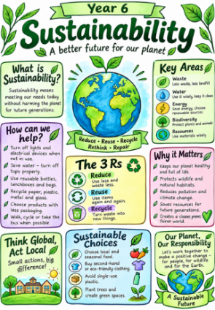
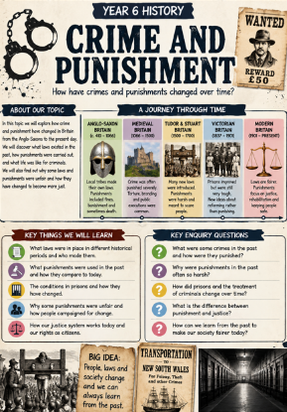
Other Information
Manor Adventure: 14th, 15th, 16th October (Wednesday to Friday)
Visit to Warwick Gaol: Tuesday, 17th November.
PE days: Tuesdays and Fridays.
Homework: set on Thursday to be handed in on Tuesday.

Themes: Sustainability and Crime and Punishment

This term, Year 6 will explore sustainability and our responsibility towards the planet, developing their understanding of how human choices can affect the natural world. In our second unit, Year 6 will explore the topic ‘Crime and Punishment’ which includes the development of the justice system.

