Holly Class Summer Homework!
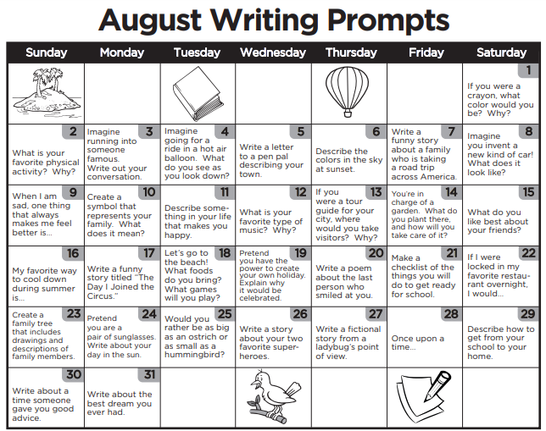
Your Summer homework task is to complete one writing challenge a day! If you miss a day, don’t worry. I wonder what you’d do if you were a crayon, or your favourite type of music…

