09.07.26 
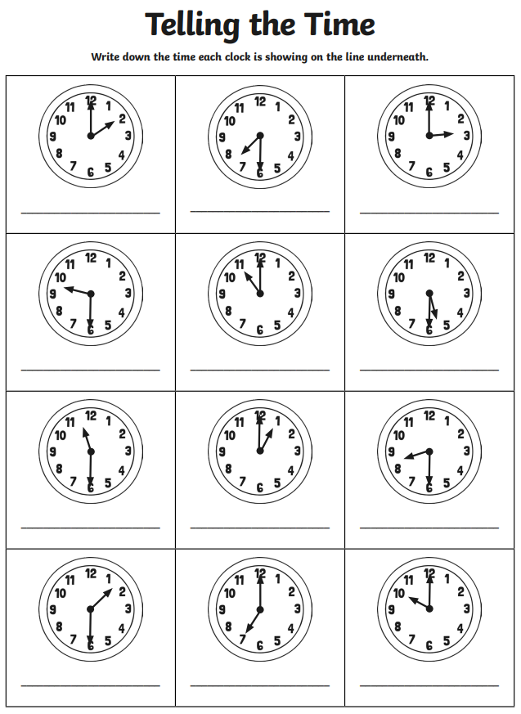
o’clock or half past?

