Year 3 Holly Class Maths Homework -YELLOW, BLUE, RED
Set 02.07.26
Due in 07.07.26
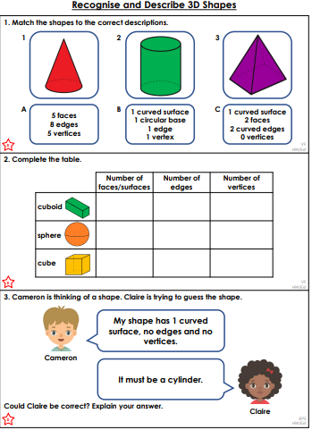
In Year 3, our last Maths unit of the year will be shape. Your homework challenge is to have a go at recognising and describing 3D shapes and their features.

Year 3 Holly Class Maths Homework -YELLOW, BLUE, RED
Set 02.07.26
Due in 07.07.26

Year 3 Holly Class Maths Homework -YELLOW, BLUE, RED
Set 02.07.26
Due in 07.07.26
In Year 3, our last Maths unit o f the year will be shape. Your homework challenge is to have a go at recognising and describing 3D shapes and their features.
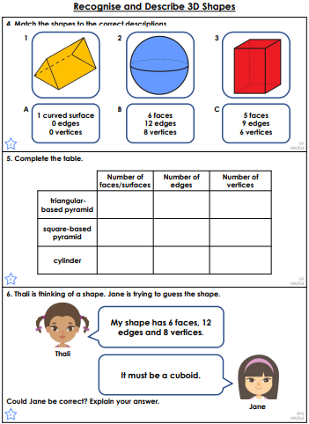

Year 3 Holly Class Maths Homework -YELLOW, BLUE, RED
Set 02.07.26
Due in 07.07.26
In Year 3, our last Maths unit o f the year will be shape. Your homework challenge is to have a go at recognising and describing 3D shapes and their features.
