25.06.26
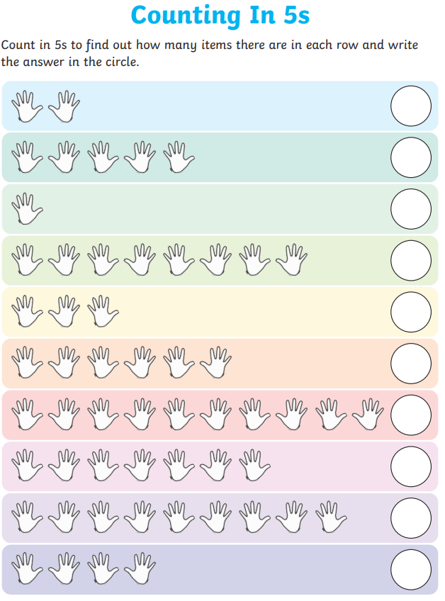
0 | 5 | 10 | 15 | 20 | 25 | 30 | 35 | 40 | 45 | 50



