Year 3 Holly Class Maths Homework -YELLOW, BLUE, RED
Set 18.06.26
Due in 23.06.26
In Year 3 this week, we have been progressing our learning of time with durations. The children have found this a hard topic! Your homework challenge is to have a go at calculating how much time has passed (duration).
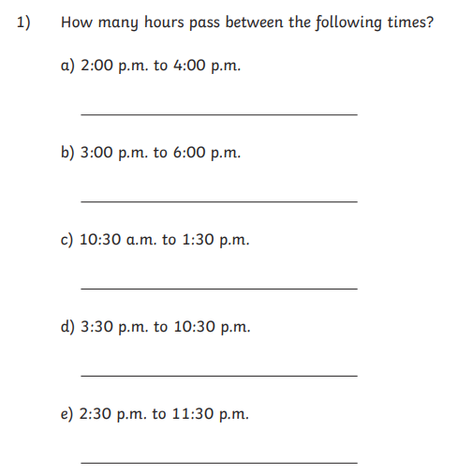

Year 3 Holly Class Maths Homework -YELLOW, BLUE, RED
Set 18.06.26
Due in 23.06.26
In Year 3 this week, we have been progressing our learning of time with durations. The children have found this a hard topic! Your homework challenge is to have a go at calculating how much time has passed (duration).
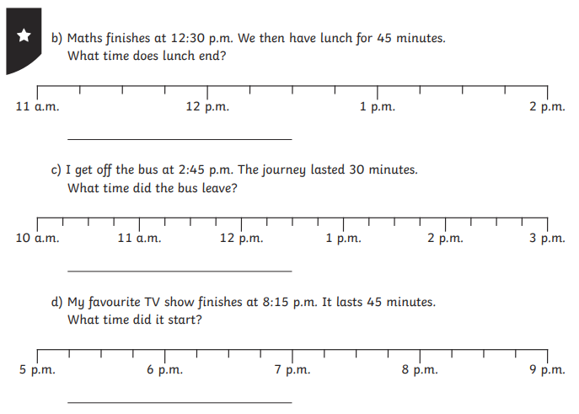

Year 3 Holly Class Maths Homework -YELLOW, BLUE, RED
Set 18.06.26
Due in 23.06.26
In Year 3 this week, we have been progressing our learning of time with durations. The children have found this a hard topic! Your homework challenge is to have a go at calculating how much time has passed (duration).
