Year 3 Holly Class Maths Homework -YELLOW, BLUE, RED
Set 04.06.26
Due in 09.06.26
In Year 3 this week, we have been progressing our learning of time with ‘past’ and ‘to’ times. Your homework challenge is to complete the clock challenges by reading them, drawing the times or problem solving with time.
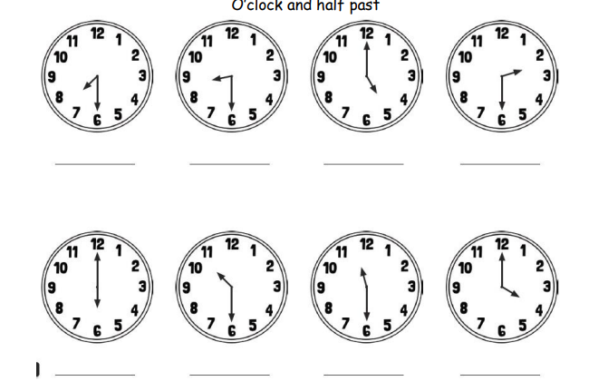

Year 3 Holly Class Maths Homework -YELLOW, BLUE, RED
Set 04.06.26
Due in 09.06.26
In Year 3 this week, we have been progressing our learning of time with ‘past’ and ‘to’ times. Your homework challenge is to complete the clock challenges by reading them, drawing the times or problem solving with time.
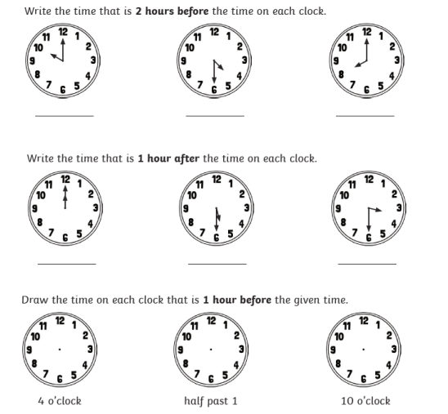

Year 3 Holly Class Maths Homework -YELLOW, BLUE, RED
Set 04.06.26
Due in 09.06.26
In Year 3 this week, we have been progressing our learning of time with ‘past’ and ‘to’ times. Your homework challenge is to complete the clock challenges by reading them, drawing the times or problem solving with time.
