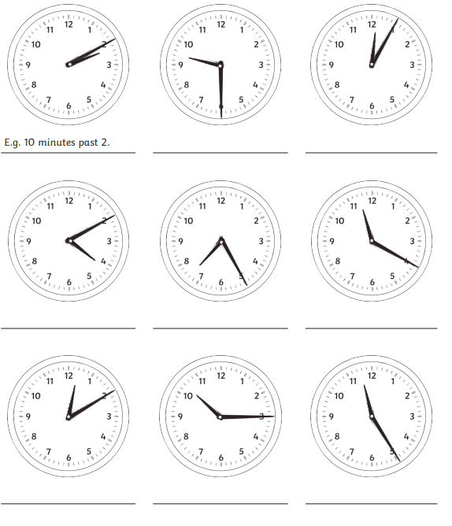

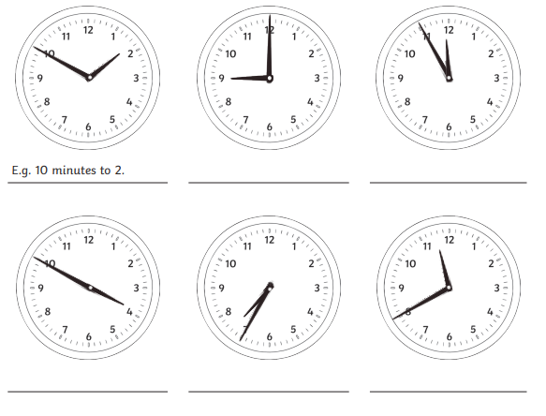
Parents: Please encourage your child to tell you the time at home at least five times over the weekend. We have been learning to tell the time in 5-minute intervals past the hour and to the hour, so they should feel confident doing this at different times throughout the day.

The key times children should already be secure with from Year 1 and Year 2 are:
o’clock
half past
quarter past
quarter to
Please write a short note to let me know how your child got on.
Thank you for your ongoing support! 😊

Parents: Please encourage your child to tell you the time at home at least ten times over the weekend. We have been learning to tell the time in 5-minute intervals past the hour and to the hour, so they should feel confident doing this at different times throughout the day.

The key times children should already be secure with from Year 1 and Year 2 are:
o’clock
half past
quarter past
quarter to
Please write a short note to let me know how your child got on.
Thank you for your ongoing support! 😊

