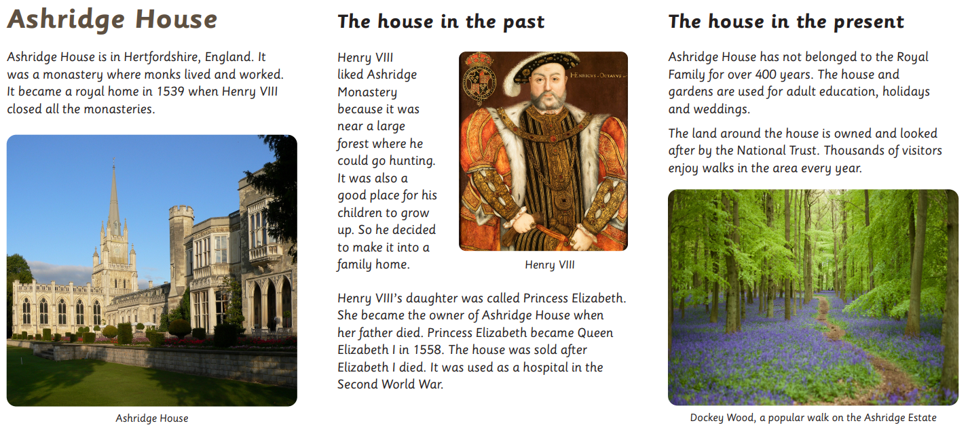

Can you explain why this house was significant using these facts – highlight them like we do in guided reading - finish the sentence on the next page.
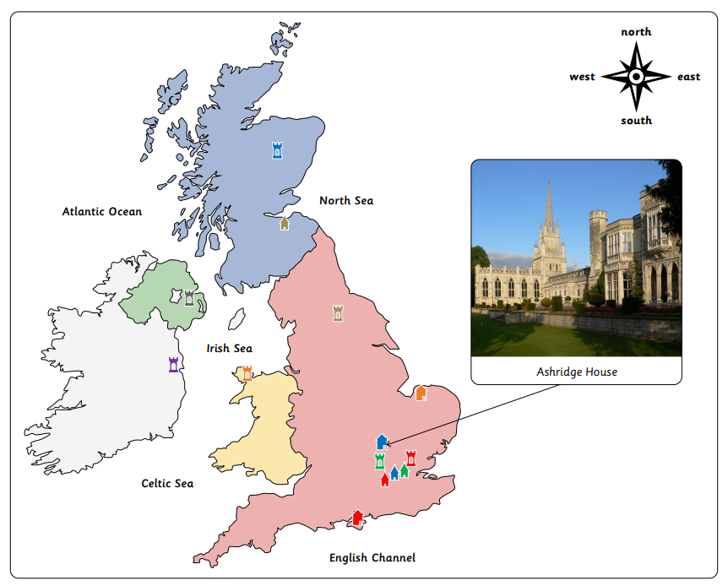
Ashridge House was significant because….

