Year 3 Holly Class English Homework -YELLOW, BLUE, RED
Set 14.05.26
Due in 19.05.26
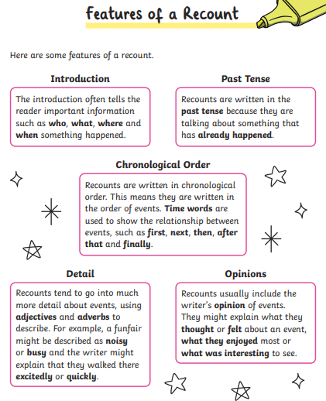
In Year 3 this week, we visited Wroxeter Roman City! Your homework is to write a recount of our trip day. Here are some features of a recount that you should include. You could decorate your recount with a Roman border, or drawings of what we got up to!

