Year 3 Holly Class Maths Homework -YELLOW, BLUE, RED
Set 07.05.26
Due in 12.05.26
In Year 3 this week, we have been progressing our learning of fractions. Your homework challenge is to complete the adding fractions questions. Remember, when they have the same denominator, the denominator does not change.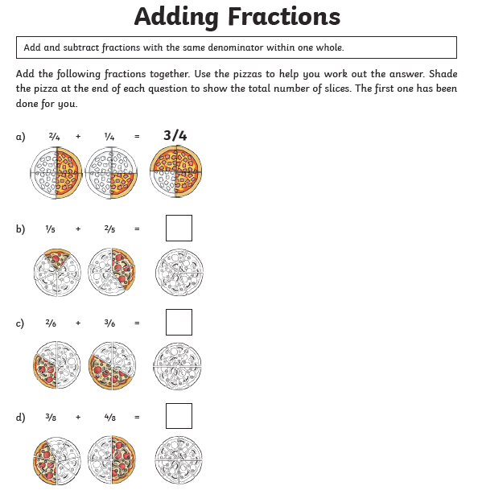
Year 3 Holly Class Maths Homework -YELLOW, BLUE, RED
Set 07.05.26
Due in 12.05.26
In Year 3 this week, we have been progressing our learning of fractions. Your homework challenge is to complete the adding fractions questions. Remember, when they have the same denominator, the denominator does not change.
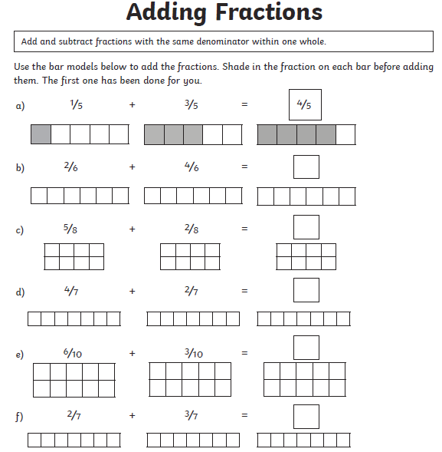
Year 3 Holly Class Maths Homework -YELLOW, BLUE, RED
Set 07.05.26
Due in 12.05.26
In Year 3 this week, we have been progressing our learning of fractions. Your homework challenge is to complete the adding fractions questions. Remember, when they have the same denominator, the denominator does not change.
