Year 3 Holly Class Maths Homework -YELLOW, BLUE, RED
Set 23.04.26
Due in 28.03.26
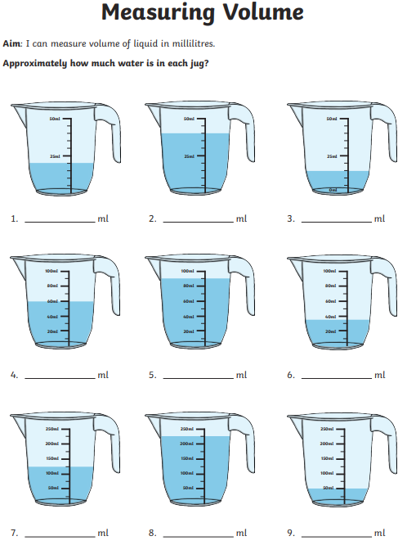
In Year 3 this week, we have been progressing our learning of measuring capacity, volume and reading intervals off a scale. Your homework challenge is to find the volume of water in each jug.

Year 3 Holly Class Maths Homework -YELLOW, BLUE, RED
Set 23.04.26
Due in 28.03.26
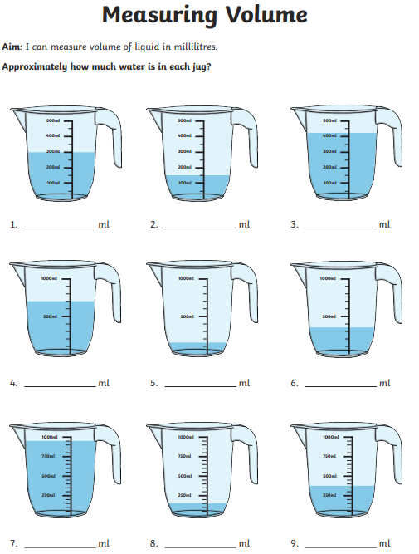
In Year 3 this week, we have been progressing our learning of measuring capacity, volume and reading intervals off a scale. Your homework challenge is to find the volume of water in each jug.
Year 3 Holly Class Maths Homework -YELLOW, BLUE, RED
Set 23.04.26
Due in 28.03.26
In Year 3 this week, we have been progressing our learning of measuring capacity, volume and reading intervals off a scale. Your homework challenge is to find the volume of water in each jug.
