Parts of a plant 23.04.26

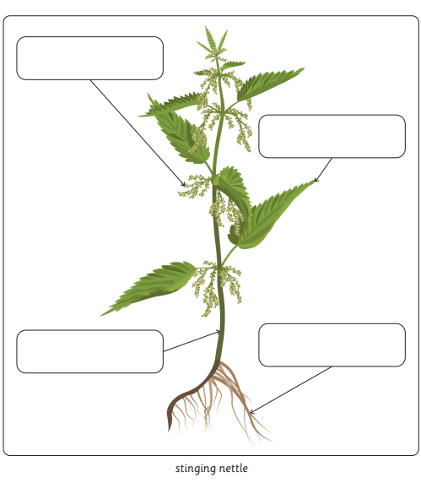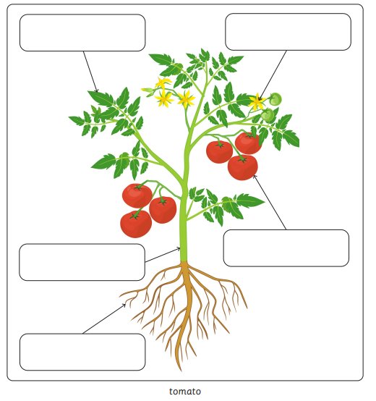
Phonics games on line to help

https://www.phonicsplay.co.uk/

https://letters-and-sounds.com/phase-4-games/

https://www.topmarks.co.uk/english-games/5-7-years/letters-and-sounds

https://www.bbc.co.uk/cbeebies/shows/alphablocks

https://www.phonicsbloom.com/

