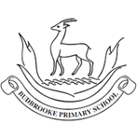
`
Maths
We will expand our knowledge of fractions by adding and subtracting fractions and finding fractions of amounts.
The children will be learning about money, including exploring the different coins we come across and converting between pounds and pence. We will apply this knowledge when we add and subtract money.
We will be looking at telling the time to the nearest minute. The children will have the opportunity to read digital clocks and use the phrases a.m. and p.m. We will explore the key words years, months, days, hours and minutes, and their relationship with each other.
The children will learn about angles and turns within shapes and we will have a go at measuring angles. We will look at different types of lines and draw polygons.
We will interpret different types of graphs.

English
Writing: We will extend our understanding of the past tense when we write diary entries. We will also be recapping the present perfect tense. We will use conjunctions, adverbs and prepositions to show time when we write biographies. We will also extend our understanding of poetry.
Reading: Our focus text is ‘The Miraculous Adventures of Edward Tulane’ by Kate DiCamillo. We will be focusing on developing our vocabulary, inference and summarising skills by exploring our focus text, as well as non-fiction texts and poems linked to our topics.
Grammar: We will be recapping the present perfect tense, prefixes and homophones.

Curriculum Newsletter
Year 3 - Holly
Summer term

History – Emperors and Empires
The children will be developing their understanding of ancient Rome. We will explore the hierarchy within society and the army during ancient Rome. The children will interrogate historical sources of information and we will discuss their reliability. We will consider the ‘Romanisation’ of Britain and the impact ancient Rome has had on modern day Britain.
RE – Islam
The children will be learning about Islam, holy places for the Islamic faith, the Qur’an and the five pillars of faith.
PSHE – Being My Best and Growing and Changing
We will consider how to keep our bodies healthy, including looking at healthy diets. We will consider our talents and strengths. We will learn some basic first aid and we will start to consider the changes our bodies go through during puberty.
MFL – My Family and My Home
The children will be learning Spanish words and phrases to support the topics of ‘My family’ and ‘My home’.
PE – Tennis and Athletics
The children will have the opportunity to develop their knowledge and skills in tennis. We will also be developing our athletics skills which will help us prepare for Sports Day.
Science – Plant Nutrition and Reproduction and Light and Shadows
The children will consider the requirements of plants for growth and survival. We will name and describe the functions of the parts of flowering plants. The children will investigate reflections and shadows. They will complete an investigation and collect data. We will consider the dangers of the sun, linking to our PSHE learning on health.
Art – Beautiful Botanicals and Mosaic Masters
We will be learning about the genre of botanical art. The children will have the opportunity to create detailed botanical paintings of botanicals. We will also learn about the history of mosaics and investigate Roman mosaics. The children will have the opportunity to develop techniques which will allow them to design and make their own mosaic border tile.
Design Technology – Greenhouse
The children will have the opportunity to explore the structure and design of greenhouses. They will learn how to use tools safely and strengthen structures. They will apply these skills in the design of their own greenhouse.
Computing – The children will be learning to use the application ‘2Simulate’ to develop their understanding of simulation and create their own. They will also be using ‘2Graph’ to develop their own graphs. The children will also be exploring the different functions within PowerPoint.
Music – In The Garden
The children will combine rhythm and pitch notation to create simple melodies. They will sing, compose, perform and notate their musical work. They will look at musical symbols including treble clef, bar lines and time signature.
Theme: Emperors and Empires

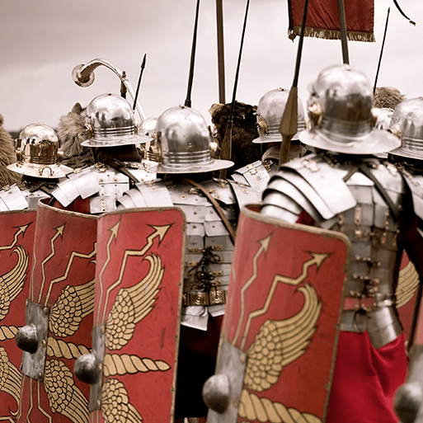.
This project teaches children about the history and structure of ancient Rome and the Roman Empire, including a detailed exploration of the Romanisation of Britain.

Other information:
We will be going to Wroxeter Roman City on Thursday 14th May to extend and apply our learning on the Romans!
Please also ensure that your child has a named water bottle in school every day as the weather gets warmer. Caps are optional, but useful for playtimes.

