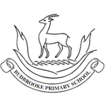
11
Maths
- Understanding decimals.
- Writing money using decimals.
- Comparing amounts of money and calculating the cost.
- Converting between analogue and digital times.
- Converting to and from the 24-hour clock.
- Understanding and identifying different angles.
- Comparing and ordering angles and finding lines of symmetry.
- Interpreting charts and drawing line graphs.
- Describing position using coordinates

English
Children will use Pugs of the Frozen North as inspiration to write narratives to continue the quest-based adventure, they will write diary entries from the point of view of different characters, non-chronological reports about Pugs and persuasive adverts about the Yeti Noodle Bar as well as poetry about wintery conditions.
In Guided Reading, children will explore vocabulary from Pugs of the Frozen North as well as developing their inference, prediction, explanation and summarising skills.

Curriculum Newsletter
Year 4 -Chestnut
Summer Term

Theme: Ancient Civilisations
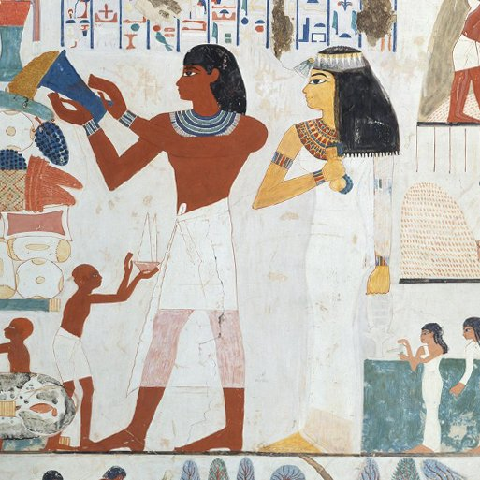
This project teaches children about the history of three of the world’s first ancient civilisations: ancient Sumer, ancient Egypt and the Indus Valley civilisation. Children will learn about the rise, life, achievements and eventual end of each civilisation
History – Ancient Civilisations
Children will learn about three of the world’s first ancient civilisations: ancient Sumer, ancient Egypt and the Indus Valley civilisation. Children will learn about the rise, life, achievements and eventual end of each civilisation.

RE - Buddhism - Living as a Buddhist and the life of Buddha.

Sikhism - Guru Granth Sahib and The Gurdwara: The first and last human Gurus.
PSHE – Being My Best/Growing and Changing
The children will look at what makes them important, understand how they can contribute to the care of the environment by recycling, understand that the body gets energy from food, water and oxygen and that exercise and sleep are important to our health. They will name positive and negative feelings, define the terms 'secret' and 'surprise' and know the difference between a safe and an unsafe secret.
PE – Netball, Athletics, Cricket & Rounders
Children will be developing their passing and shooting skills as well as applying defending and attacking tactics in game situations. They will develop their techniques for sprinting, jumping and throwing and learn the skills needed for a game of rounders and cricket.
MFL- My Family/My Home
Children will learn to introduce family members in Spanish by saying their name and age. They will describe where they live, the different rooms of the house and the objects they would find in each room.
Science – Electrical Circuits and Conductors
Children will learn about electrical appliances and safety. They will construct a simple series of circuits and name their parts and functions, including switches, wires and cells. The children will investigate electrical conductors and insulators and identify common features of conductors.
Art - Statues, Statuettes and Figurines /Islamic Art
Children will learn about the 3-D representation of the human form, including statues, statuettes and figurines. They will study examples from ancient civilisations and use their clay skills to create a Sumer-style figurine.
Children will also learn about the features of Islamic art to make geometric patterns and motifs on paper, with fabric and in clay.
Design Technology – Tomb Builders
Children will learn about simple machines, including wheels, axles, inclined planes, pulleys and levers, exploring how they helped ancient builders to lift and move heavy loads.
Computing – Effective Searching/Hardware Investigators/Making Music
Children will be locating information on the search page and assessing whether the information is true and reliable. They will also be understanding the different parts that
make up a desktop computer and to compose an electronic piece of music.
Music – Ancient China
Children will learn about the pentatonic scale and harmonious sounds through composing, singing and performing. They will combine rhythm and pitch notation to record their music inspired through the exploration of Ancient Chinese music, philosophy, myths and rituals.

Other Information
PE Days: Tuesday. Children will need to wear PE kit to school on this day.
New homework and spellings handed out on Thursday and are to be handed in by the following Tuesday.
School Trip to Birmingham Art Gallery for The Mysteries of Ancient Egypt; Drama and History on Thursday 2nd July 2026.

