Length and Height 16.04.26 
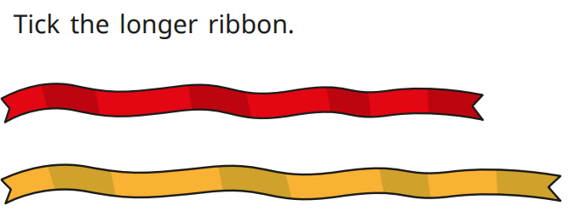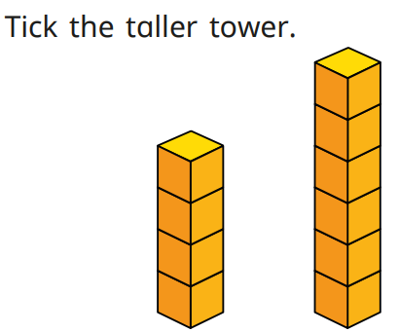

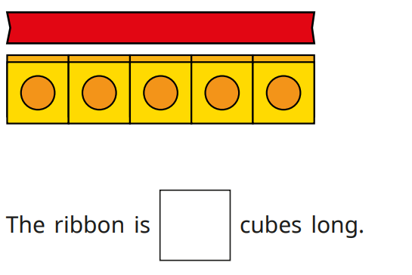

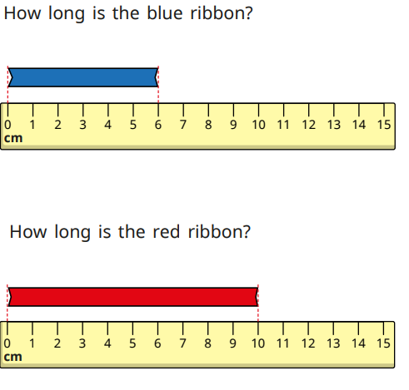
Can you measure the length or height of items in your home? You can use a ruler (cm) or a non standard measure e.g. pasta, paper clips, lego.

