Year 3 Holly Class Maths Homework -YELLOW, BLUE, RED
Set 19.03.26
Due in 24.03.26
In Year 3 this week, we have been progressing our learning of fractions, including finding the parts to make a whole (1). Your homework challenge is to label and complete the fraction lines.

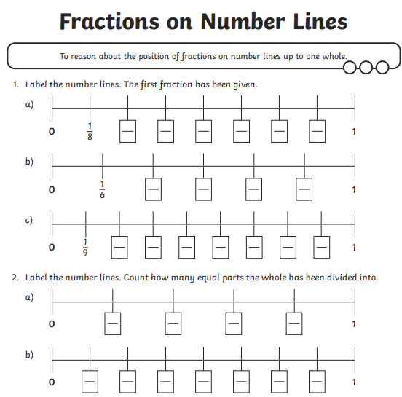

Year 3 Holly Class Maths Homework -YELLOW, BLUE, RED
Set 19.03.26
Due in 24.03.26
In Year 3 this week, we have been progressing our learning of fractions, including finding the parts to make a whole (1). Your homework challenge is to label and complete the fraction lines.

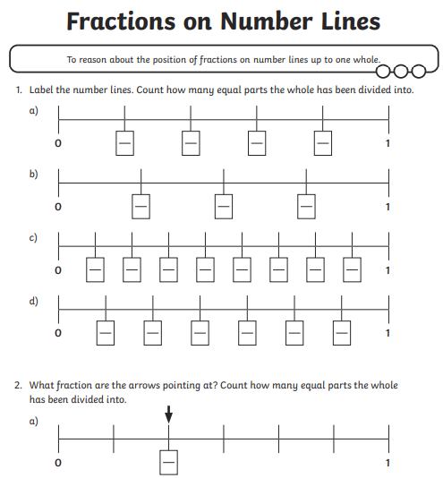

Year 3 Holly Class Maths Homework -YELLOW, BLUE, RED
Set 19.03.26
Due in 24.03.26
In Year 3 this week, we have been progressing our learning of fractions, including finding the parts to make a whole (1). Your homework challenge is to label and complete the fraction lines.
