London Landmarks 12.03.26
Can you draw some London landmarks on your map. Don’t forget the river Thames! Some have been drawn for you. What are they called? Can you locate a landmark on the map and explain to someone how to get there from a different place? Can you use the location words e.g. next to, above, behind, in between and directional words e.g. forwards, backwards, left and right and words such as go, stop and turn?
 |  | 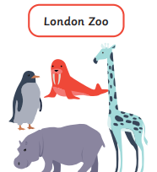
 |  |  | 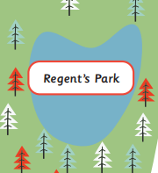 |  |  | 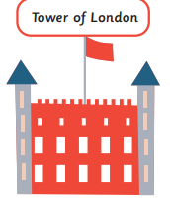
 | 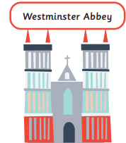 |  |  |  |  | 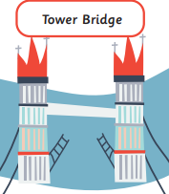
 |  |  |  |  | 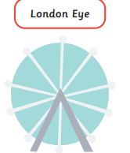 | 