Year 3 Holly Class Maths Homework -YELLOW, BLUE, RED
Set 05.03.26
Due in 10.03.26
In Year 3 this week, we have started our learning about fractions, particularly non-unit fractions (where the numerator is 1). Your homework challenge is to complete the unit fraction questions in your homework book.
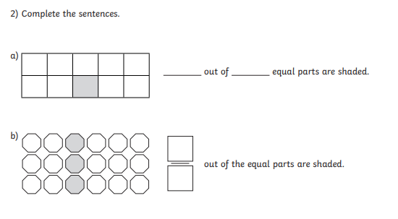
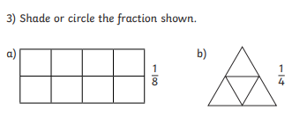

Year 3 Holly Class Maths Homework -YELLOW, BLUE, RED
Set 05.03.26
Due in 10.03.26
In Year 3 this week, we have started our learning about fractions, particularly non-unit fractions (where the numerator is 1). Your homework challenge is to complete the unit fraction questions in your homework book.
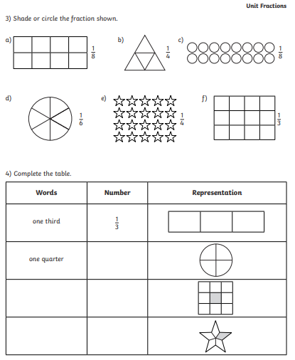

Year 3 Holly Class Maths Homework -YELLOW, BLUE, RED
Set 05.03.26
Due in 10.03.26
In Year 3 this week, we have started our learning about fractions, particularly non-unit fractions (where the numerator is 1). Your homework challenge is to complete the unit fraction questions in your homework book.

