Maths homework- Yellow
Handed out: 22.01.26
To be handed in by: 27.01.26
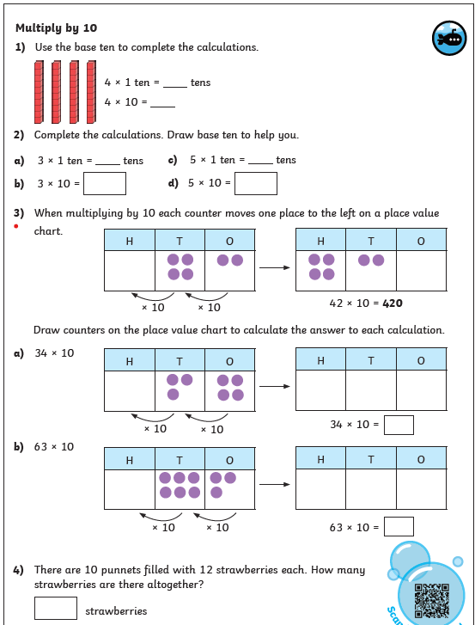
This week we have been multiplying numbers by 10. Your homework challenge is to use the place value charts to work out the answers.

