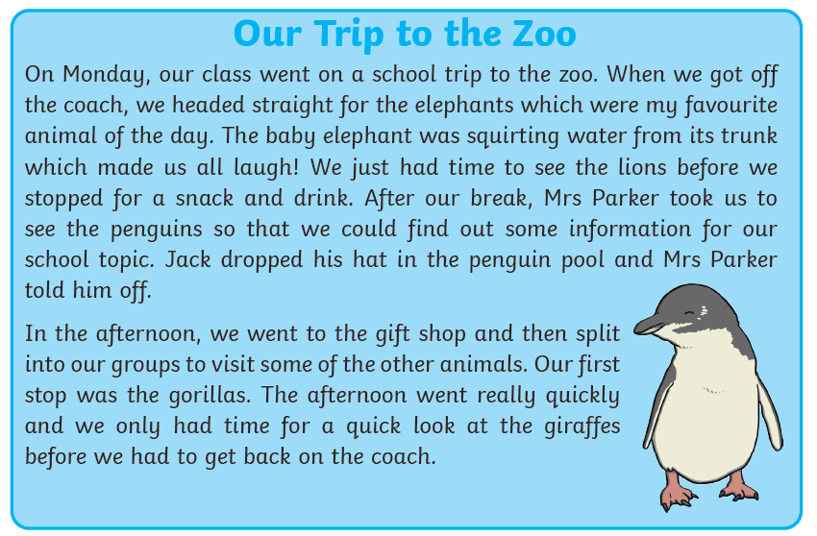
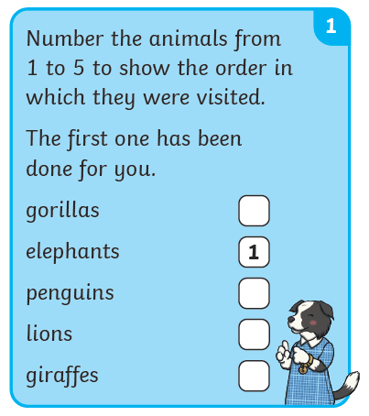
2. What did the class do before they saw the elephants?
3. 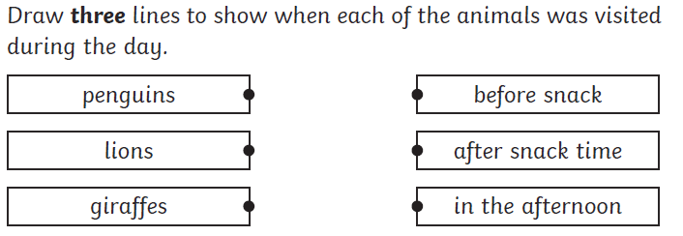
4. Look at the whole recount.
Number the sentences from 1 to 5 to show the order in which they happen.

The first one has been done for you.
Jack dropped his hat in the penguin pool.
The children arrived at the zoo. 1
The baby elephant was squirting water from its trunk.
The children visited the gift shop.
The children stopped for a snack and a drink.

