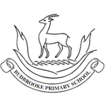
Maths
Children will be learning a range of skills related to multiplication and division including efficient ways t6 multiply multi digit numbers as well as division with remainders. We will then move onto to investigating multiplying fractions.
After half term we will begin learning about the relationship between fractions, decimals and percentages. Then onto perimeter and area and statistics.

English
The children will develop their grammar, punctuation and spelling skills through a rich and engaging study of Charlotte’s Web. Using the text as a stimulus, children will explore how authors create characters, build atmosphere and convey meaning through carefully chosen language. Children will produce a range of purposeful writing outcomes inspired by the story. These include a non-chronological report linked to animals and farm life, diary entries written from the viewpoint of key characters, and an extended argument exploring themes, viewpoints and moral choices within the text. Children will also analyse characters in depth, using evidence from the story to justify opinions and interpretations.

Curriculum Newsletter
Year 5 -Redwood
Spring Term

Other Information
PE day: Wednesday
New homework and spellings are given out on Thursday and are to be handed in/tested on Tuesday.
Geography – Sow, Grow and Farm
The children will be learning all about the features and characteristics of land use in agricultural regions across the world, including a detailed exploration of significant environmental areas. We will look at include allotment use, how agricultural land is used in different climates and farming in the UK.
RE – Sacred Writings
In RE the children will be investigating the sacred texts of different religions. These will include how sacred texts are treated in different religions, considering how the Qu’ran is important to Muslims, who and why Gura Granth is important and the construction of the Bible. Children will also learn about what different religions learn from these texts.
PSHE – Keeping Safe/Rights and Respect
Children will be learning how to deal with risky situations that could happen online and what they can do to make them less risky. Children will also consider the risks of legal drugs (e.g. alcohol). Children will learn about people’s rights, how to respect themselves.

PE - Dance
Children will learn different styles of dance, working individually, as a pair and in small groups. In dance as a whole, pupils think about how to use movement to explore and communicate ideas and issues, and their own feelings and thoughts. Children will be provided with the opportunity to create and perform their work. They will be asked to provide feedback using the correct dance terminology and will be able to use this feedback to improve their work.
MFL Little Red Riding Hood/Weather
In this unit pupils will learn to listen carefully so as to understand a familiar fairy tale recounted in Spanish using picture and word cards. Pupils will be exposed to more language and be encouraged to use mind-mapping activities to support their learning. After half term children will learn the knowledge and skills to describe the weather in Spanish and to also present a weather forecaster pretending to be on television. This enables us to link the weather vocabulary with map work, compass points and general geography.

Science – Human reproduction and aging
Children will learn about animal life cycles, including the human life cycle. They explore human growth and development to old age, including the changes experienced during puberty and human reproduction

Art – Line, light and shadow/Natures art
The children will learn about the visual qualities of line, light and shadow. They explore the work of Pablo Picasso and Rembrandt and are introduced to a range of shading techniques. They take black and white photographs and use pencil, pen and ink wash to reimagine their photographs in a shaded drawing.
After half term children will learn about the genre of land art. They will work outdoors to sketch natural forms and explore the sculptural potential of natural materials before working collaboratively to create land art installations.
Design Technology – Eat the Seasons
Children will learn about the meaning and benefits of seasonal eating, including food preparation and cooking techniques. This will include creating recipes and learning the skills needed to prepare food as well as evaluating the final product.

Computing – Databases/Game Creator
Children will be using database program to learn about the functions of databases, they will learn how to search and create their own. After half term children will design and create a simple computer game including designing the game environment and the game quests within it

Music – Composing and chords/Exploring musical styles
Children will learn that if we play three or more pitches together, we can create chords in music. Chords provide the basis for accompaniment in music. By using chords in compositions, we can create music that is really interesting. In this unit we will create an accompaniment and the composition extension activities will help you to learn about chords.
After half term children will learn about some of the many different, wonderful and interesting styles of music. Children will learn about the word ‘Texture’ and that it refers to the layers of sound you hear in a piece of music. textures.
We will explore how voices and instruments combine to create texture in music.

Theme: Grow Sow and Farm
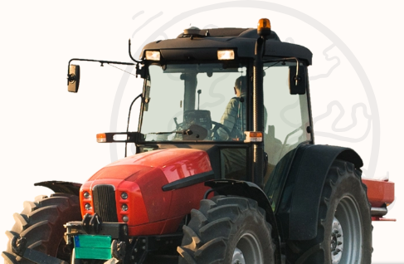
Our main project teaches children about the features and characteristics of land use in agricultural regions across the world, including a detailed exploration of significant environmental areas. Our topic links lots of our curriculum areas together including our text – Charlotte’s web with themes of farming. Our science work on animal life cycles will bring together the rich vocabulary found throughout the unit and our investigative skills.

