
Maths
Shape
Count and compare different amounts of money.
Multiplication and Division
Explore and use arrays to support multiplication.
Make equal groups and divide by sharing and grouping objects.
Multiply and divide by 2, 5 and 10.
Length and Height
Measure in centimetres and metres.
Compare and order lengths and heights.
Add, subtract, multiply and divide to complete calculations linked to length and height.

English
Reading
Our class text is The Storm Whale by Benji Davis. We will also read a range of non-fiction texts and poetry.
Writing
We will write a diary entry, a story and a poem about a storm. We will focus on becoming more accurate when using subordinating conjunctions, expanded noun phrases and commas in lists.

Curriculum Newsletter
Year 2 -Beech
Spring Term

History –
Not covered this half term
Geography – Coastline
Use simple compass directions.
Read and draw simple maps that use a key.
Describe the effects of erosion.
Describe how a coastal town has changed over time.
Describe the function of tourism in a coastal town.
RE – Special Words and Stories
Express our own identity and belonging through stories, nursery rhymes and songs.
Explore the special books and stories of Christianity, Judaism and Sikhism.
PSHE – Keeping Safe & Rights and Respect
Recall rules for keeping physically safe when using medicines.
Explore how to treat oneself and others with respect.

PE – Gymnastics & Dance
Perform shapes and link them to form sequences. Create a short dance phrase showing expression and character.

Science – Uses of Materials & Plant Survival
Describe how some materials can be changed.
Compare the suitability of materials to suit a particular purpose.
Identify what plants need to stay grow and stay healthy.
Art – Flower Head
Create a range of shapes, forms, patterns and textures.
Paint and sculpt natural forms from observation and from imagination.
Design Technology – Beach Hut
Explore how structures can be made stronger, stiffer and more stable.
Design, make and evaluate a beach hut.
Computing–Questioning and Effective Searching
Use data handling skills to create a binary tree.
Recognise that digital content can be stored and retrieved.
Gain a better understanding of searching on the Internet.
Music – The Ocean
Sing simple songs and chants including sea shanties. Play tuned and untuned percussion instruments. Star words this term are: chorus, notation and pitch

Theme: Coastline
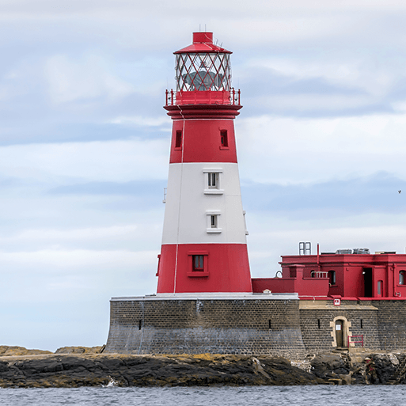

This project teaches children about the physical and human features of coastal regions across the United Kingdom, including a detailed exploration of the coastal town of Whitby, in Yorkshire.
Other Information. P.E. days: Mondays.
Home Learning: new home learning tasks will be set on a Thursday to be handed in on the following Tuesday.

