
Personal, Social & Emotional Development
Build constructive and respectful relationships and talk about the special people in their lives and why they are important.
Play cooperatively with others and take turns.

Communication & Language
Listen attentively and respond to what they hear with relevant questions, comments and actions when being read to and during whole class discussions and small group interactions.
Develop storylines in their pretend play and use conversations and discussion to help solve problems, organise thinking and activities and explain how things work and why they might happen.

Curriculum Newsletter
Reception - Maple
Spring 1 2026

Physical Development
Use a variety of marks to represent the human form, from observation, imagination or memory.
Pat, throw, kick, pass, aim, bat and catch different sized balls with increasing contro
Understanding of the World
Show an awareness of the similarities and differences between people in different communities and groups from around the world.

Discuss how the local environment has changed over time using photographs and first-hand experiences.
Expressive Arts & Design

Sing well-known songs and nursery rhymes in a group or on their own, increasingly matching the pitch and following the melody.

Construct simple structures and models using a range of materials.

Literacy
Write recognisable letters, most of which are correctly formed, using a tripod grip to form lower-case and capital letters in almost all cases.

Use writing to communicate thoughts, ideas, experiences and events.

Reread books to build up their confidence in word reading, their fluency and their understanding and enjoyment.
Mathematics
Composing, representing and subitising numbers to 8.

Mass and Capacity – comparing mass, finding a balance, exploring and comparing capacity.

Odd and even numbers, doubles and halves to 8.
Explore how to share amounts evenly using concrete resources.
Theme: Long Ago
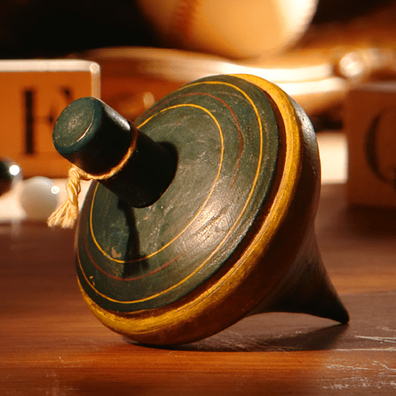

This project teaches children about how they have grown and changed since they were babies and how life in the past was different from today
Other Information
PE – Tuesdays (Children to arrive to school in PE kit)
Welly Walks – usually Fridays, dependent on weather.
Please bring a filled water bottle in each day, this will be sent home every afternoon.

