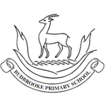
Maths
- Multiplying and dividing by 10 and 100.
- Multiplying a 2 and 3-digit number by a 1-digit number.
- Dividing a 2 and 3-digit number by a 1-digit number.
- Measure in kilometres and metres and finding equivalent lengths.
- Finding the perimeter of a variety of shapes.
- Understand improper fractions and convert mixed numbers into improper fractions.
- Adding and subtracting using fractions.
- Understanding decimals.
English
Children will write an information page about the Amazon Rainforest. They will debate and write a balanced argument about cutting down trees. They will also write a diary recount about a trip down the river using noun phrases to describe the setting. They will also create information leaflets about mountains using fronted adverbials and write an explanation piece about the water cycle.
In Guided Reading, children will explore vocabulary from The Great Kapok Tree as well as developing their inference, prediction, explanation and summarising skills.

Curriculum Newsletter
Year 4 -Chestnut
Spring Term

Geography – Rivers and Mountains
Children will learn about the different parts of a river as well as explaining how the physical processes of a river, sea and ocean have changed a landscape. They will name and locate significant rivers and mountains from around the world and explain how the rivers and canals are used.

RE – Christianity
Children will learn about who was Jesus, parables, two greatest commandments, Lord’s prayer and the last week of Jesus’ life
PSHE – Keeping Safe / Rights and Respect
Children will learn to identify situations that are dangerous, risky or hazardous. They will understand who can help them manage risk, understand the consequences of behaving in an unacceptable, unhealthy or risky way and continue to learn about the importance of online safety and the implications of sharing images online without consent. Children will learn about who helps us to say healthy and safe.
My Happy Mind- Appreciate
PE – Gymnastics & Dance./ Handball with Onside
Children will develop balances, rotation jumps, rolls and use of the gymnastics apparatus. They will develop a dance using matching and mirroring, as well as using actions, dynamics, space and relationships to represent a state of matter.

MFL- Vegetables
Children will learn 10 common vegetables in their plural form with their definite articles. They will learn the basic transactional language required take part in a role-play activity based on buying different quantities of vegetables from a market stall.
Science – States of Matter/ Grouping and Classifying
Children will learn about solids, liquids and gases and their characteristic properties. They will observe how materials change state as they are heated and cooled, and learn key terminology associated with these processes. They will also group living things, known as classification. They will study the animal and plant kingdoms and use and create classification keys to identify living things.

Art – Vista / Animal
Children will learn about the techniques that artists use when composing landscape images, such as colour and atmosphere.
They will also learn about the historical and cultural portrayal of animals in art. They will study the visual qualities of animals through sketching, printmaking and clay modelling.
Design Technology – Functional and Fancy Fabrics
Children will learn about home furnishings and the significant designer William Morris. They will also learn techniques for decorating fabric, including block printing, hemming and embroidery and use them to design and make a fabric sample.
Computing – Writing for Different Audiences, Logo and Animation
Children will write for different audiences including using font styles to produce a news report. They will use 2Logo to create letter shapes and use 2Animate to create stop-motion animation.

Music – Compose with Your Friends.
Children will learn about composing music, using the ‘tonic pitch’ or the ‘home note’ and making a melody. They will practice listening, singing, and playing instruments to explore this important note in music using a selection of notes: C, D, E, F, F♯, G, A, B♭, B

Other Information
PE days: Tuesdays . Children will need their PE kits in school at all times. New homework and spellings are given out on Thursdays and are to be handed in by the following Tuesday.

Theme: Misty Mountain, Winding River
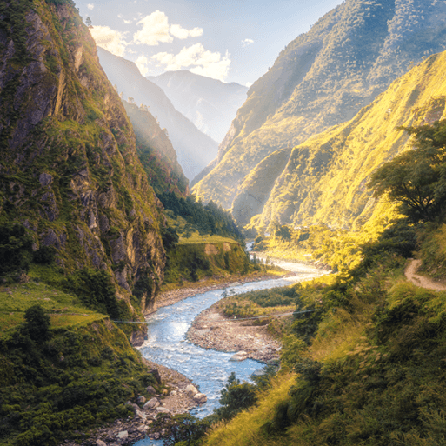

This project teaches children about the characteristics and features of rivers and mountain ranges around the world, including a detailed exploration of the ecosystems and processes that shape them and the land around them.

