Maths homework- Yellow
Handed out: 04.12.25
To be handed in by: 09.12.25
We have been continuing to build on our confidence with times tables. Your challenge is to complete the multiplication wheels for each times table.
Extra challenge- write the corresponding division facts.
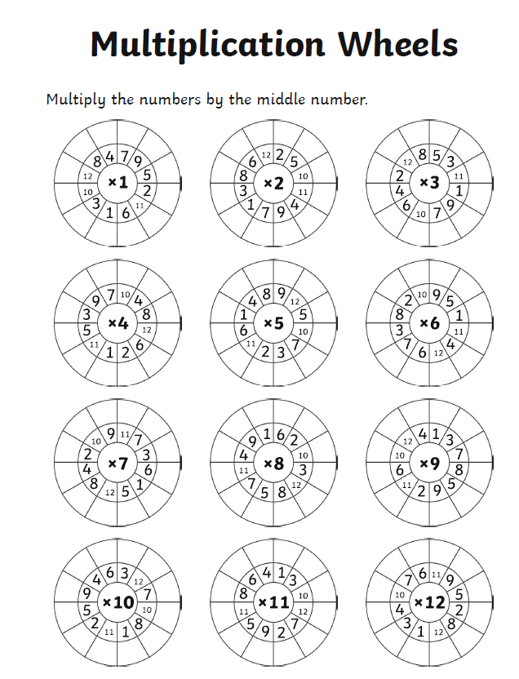
4 X 6 = 24 24 ÷ 6 = 4

