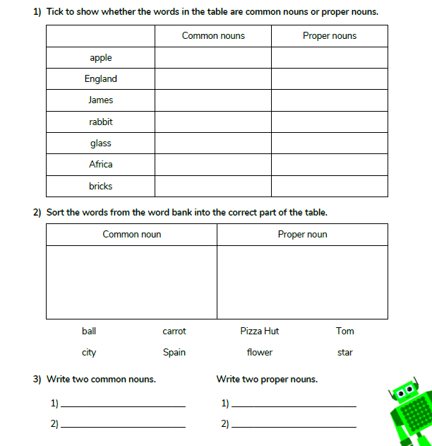
Challenge:
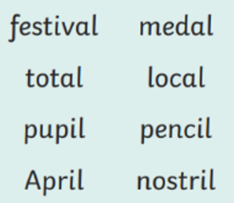
Can you put this week’s spelling words into alphabetical order?
Can you write a sentence with each word in remembering correct sentence formation?
Can you put the words into the correct syllable formation?
_ _ _/_ _/_ _ _ _ _/_ _ _
_/_ _ _ _ _ _/_ _ _
_ _/_ _ _ _ _ _/_ _ _
_ _/_ _ _ _ _ _/_ _ _ _

