Year 3 Holly Class Maths Homework -RED
Set 27.11.25
Due in 02.12.25
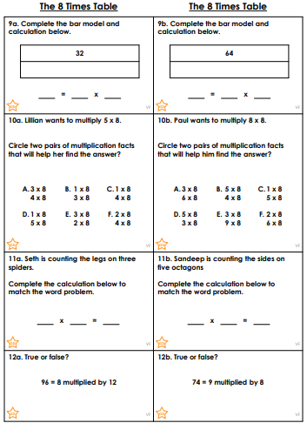
In Year 3 this week, we have been embedding our knowledge of the 8 times tables. Holly Class have been doing so well in Maths recently. Your homework challenge is to answer the questions below, in your homework book.

