Year 3 Holly Class English Homework -YELLOW
Set 20.11.25
Due in 25.11.25
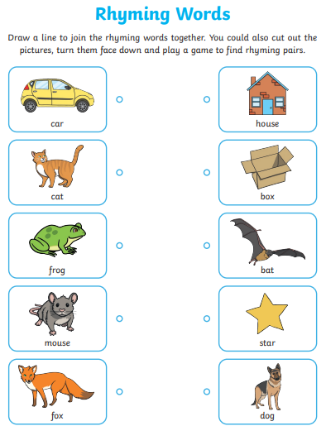
In Year 3 this week, we have started our topic of Poetry. Holly Class have been starting to write their own poems after looking at common features, including rhyming. Your homework challenge is to answer the questions below, in your homework book.

