English Homework – Yellow
Handed out: 13.11.25
To be handed in by: 18.11.25
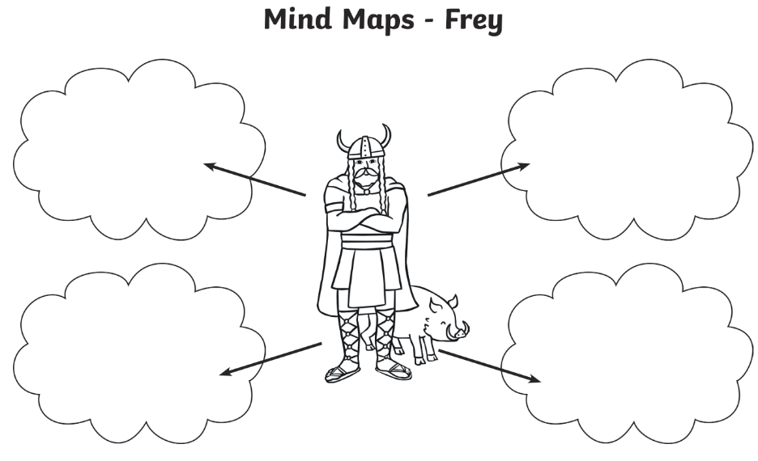
We will be writing narratives based on Norse myths. Your homework challenge is to choose one of the Norse Gods below and label with adjectives to describe the gods as well as any other information you know or can find out.
