Year 3 Holly Class English Homework -RED

Set 16.10.25

**Due in 21.10.25**

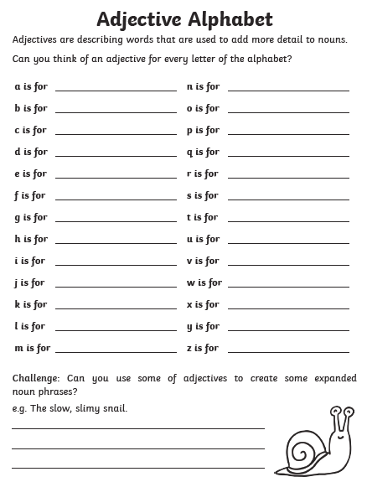In Year 3 this week, we have been finding, selecting and using powerful adjectives to describe settings. Your homework challenge is to write an adjective for every letter of the alphabet! For example: amazing, beautiful, curious. Write them into your homework book.