Year 3 Holly Class Maths Homework -YELLOW

Set 09.10.25

**Due in 14.10.25**

In Year 3 this week, we have been building our knowledge of adding and subtracting with regrouping. Your homework challenge is to practise adding and subtracting with regrouping.

**For adding, remember: too much on the floor, pass it next door!**

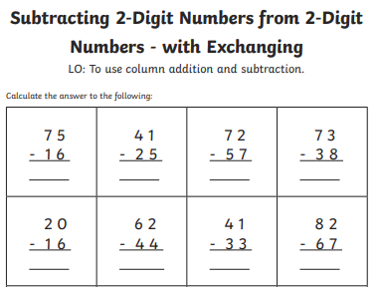**For subtracting, you can break the ten or the hundred!**