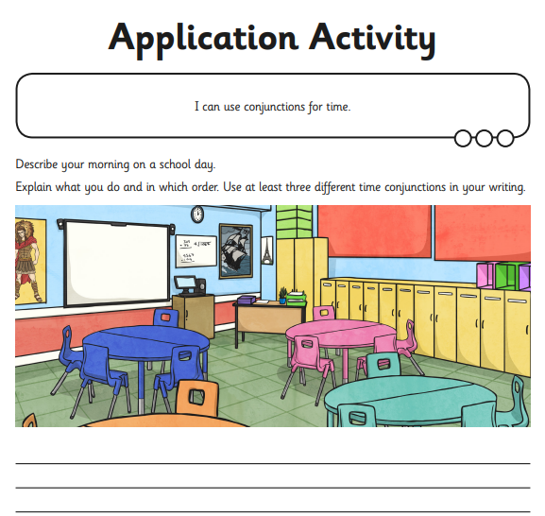Year 3 Holly Class English Homework - YELLOW

Set 02.10.25

**Due in 07.10.25**

In Year 3 this week, we have used time conjunctions (first, next, lastly) to sequence our writing. Your homework challenge is to use appropriate conjunctions in your sentences. Please complete the questions neatly, in your homework book.