Year 3 Holly Class English Homework - YELLOW

Set 18.09.25

**Due in 23.09.25**

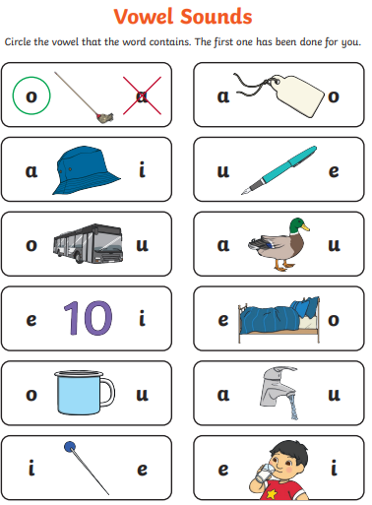In Year 3 this week, we have been looking at vowels (a, e, i, o, u) and consonants (all other 21 letters of the alphabet). Your homework challenge is to practise identifying vowels within words and **circle the correct vowel that is within each word**. Please complete the questions neatly, in your homework book.