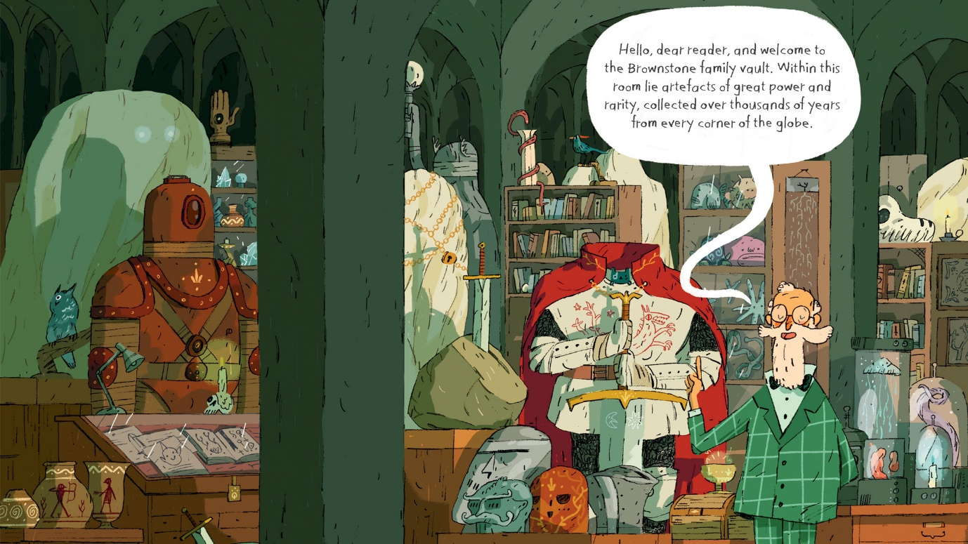**Examples of artefacts**

**Persuasive sentence openers**

* Clearly,
* I guarantee
* It is extremely evident that
* Everybody knows
* I am absolutely certain that
* In my personal opinion
* It is vitally important that
* The fact of the matter is
* Others agree that
* Without a doubt
* Let me reiterate
* My main point is that
* I feel extremely confident that
* It is quite obvious that
* I must say that
* It is clear that
* On the one hand
* I feel extremely confident that
* People around the world understand that
* I strongly believe
* Overall, it is clear
* I am positive that