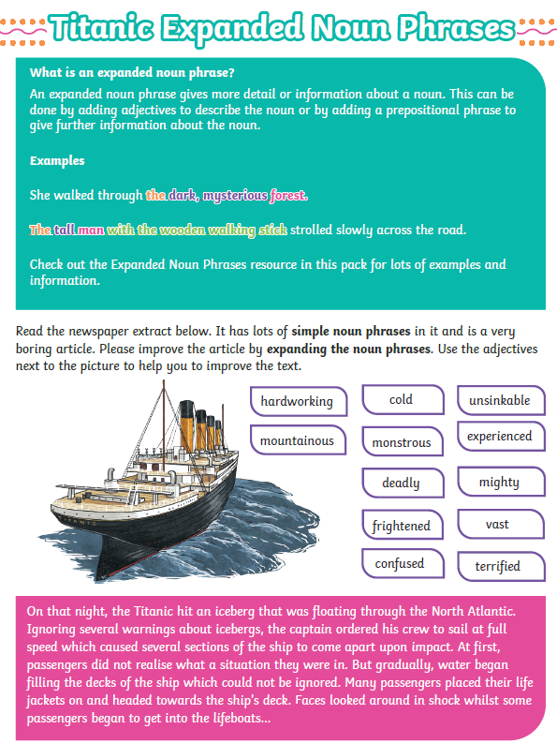

Read the text below and use it to write your own expanded noun phrases about the Titanic.