

**Personal, Social & Emotional Development**

Awareness of own feelings and the feelings of others.

Show confidence to try new activities, show independence, resilience and perseverance.

Name special people in their lives.

Describe different feelings.

**Communication & Language**

Offer explanations for why things might happen, making use of recently introduced vocabulary from stories, non-fiction, rhymes and poems when appropriate.

Listen attentively and respond to what they hear with relevant questions, comments and actions when being read to and during whole class discussions and small group interactions.

**Curriculum Newsletter**

**Reception -Maple**

**Autumn 1 2025**

|  |
| --- |
| **Physical Development**  Begin to show accuracy and care when drawing.  Use a range of large and small apparatus indoors and outside. |
| **Understanding of the World**  Describe their immediate environment using knowledge from observation, discussion, stories, non-fiction texts and maps.  Explain some similarities and differences between life in this country and life in other countries, drawing on knowledge from stories, non-fiction texts and – when appropriate – maps. |
| **Expressive Arts & Design**  Safely use and explore a variety of materials, tools and techniques, experimenting with colour, design, texture, form and function.  Share their creations, explaining the process they have used. |

|  |
| --- |
| **Literacy**  Enjoys looking at books and sharing stories.  Anticipate – where appropriate – key events in stories.  Talk about stories and make connections with events in their own lives or other familiar stories.  Read some individual letters by saying the sounds for them. |
| **Mathematics**  Key times of the day and class routines.  Positional language – where do things belong?  Match, sort and comparing amounts.  Comparing size, mass and capacity.  Exploring patterns. |

**Theme: Let’s Explore**

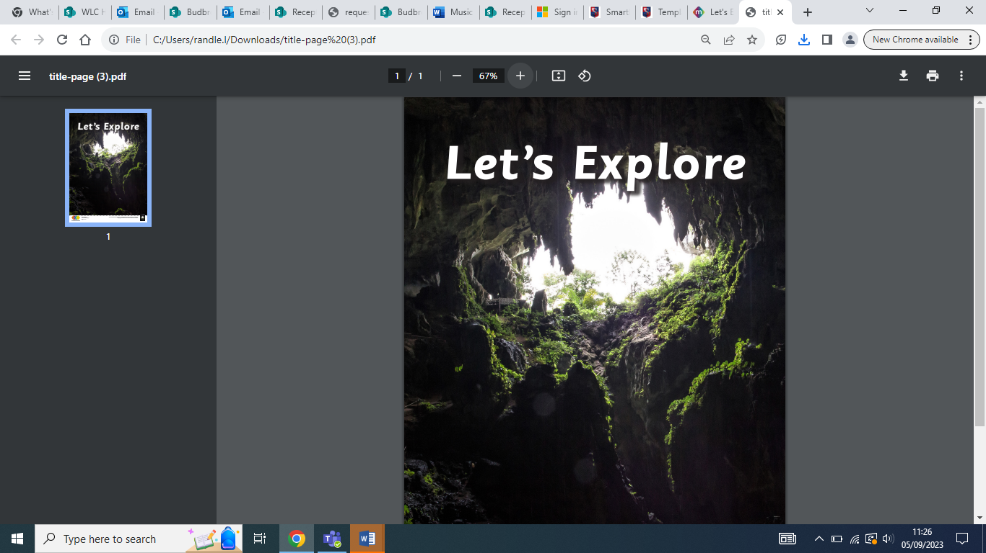

This project teaches children about the environments that they share with others, including their homes, school and places in the local community.

**Other Information**

**PE** – PE will take place on Tuesdays.

**Reading Folder –** Please practise your child’s weekly phonics sounds in their phonics book and home reading.