

**Maths**

Children will be sequencing Roman Numerals up to 1000. They will compare and order numbers to 1,000,000.

They will be adding and subtracting whole numbers with more than four digits and will be using this learning to solve and compare calculations. They will also revise using inverse operation to help with multiplication and division problems.

They will be using their knowledge of Multiplication to find common multiples and will learn about prime, square and cube numbers.

**English**

We will be using a short film to inspire writing using figurative language. We will be learning how to use language and grammar forms to engage our listener and perform the poems to an audience. Redwood will also dive into the world of Science Fiction and create a narrative. They will use a variety of verbs forms and will focus on how to create a setting that engages the reader. In addition, Redwood will research famous Chinese leaders and create a biography using relative clauses to improve their sentences.

Reading sessions will be linked to class text of Cosmic where we apply our prediction, inference, and summarising skills.

**Curriculum Newsletter**

**Year 5 -Redwood**

**Autumn Term**

Other Information

PE days: Tuesday and Wednesday

New homework and spellings are given out on Wednesdays and are to be handed in on Mondays.

|  |
| --- |
| **Geography – Investigating our world**  During the Investigating Our World project, Redwood will study Ordnance Survey maps to write a description of the local area. They will learn about contour lines and revise six-figure grid references to locate features on maps. Redwood will also learn about climate zones, vegetation belts and biomes. They will find out that the climate and vegetation in an area determine the animals that live there. |
| **RE**  Children will learn about the Life-changing experiences for founders of different religions. This will include the Baptism of Jesus (Christianity) and the Buddha achieving enlightenment (Buddhism) |
| **PSHE – Me and My Relationships / Valuing Differences**  Children will be identifying different strategies to help them collaborate and discuss how they can resolve difficult situations with their friends and peers. They will learn what acceptable online behaviour is and how to take responsibility about their actions online. They will also identify the best qualities of a friend and learn to use those qualities to improve their relationships. |
| **PE**  Children will learn and develop their ball skills, reactions and balancing skills as well as how to react positively to overcome challenges and persevere even when things get difficult. |
| **MFL**  Redwood will be learning 10 familiar activities that they know how or do not know how in Spanish. They will also learn how to present both orally and in written form about the pets they have and/or do not have. |

|  |
| --- |
| **Science – Forces and Mechanisms**  In the Forces and Mechanisms project, Redwood will revisit prior learning about forces. They will learn that gravity is a force of attraction and follow instructions to observe gravity in action.  **Earth and Space**  In the Earth and Space project, Redwood will learn the names of the planets in the Solar System before creating a model outdoors to describe its scale, movement and features. They will learn how scientists throughout history used different methods to study the Solar System and came to understand how the planets orbited the Sun. |
| **Art – Tints, Tones and Shades**  Redwood will learn about colour theory by studying the colour wheel and exploring mixing tints, shades and tones.  **Taotie**  Children will learn about the significance and art of the taotie motif, including ancient and contemporary casting methods. |
| **Design Technology – Moving Mechanisms**  Children learn about pneumatic systems. They experiment with pneumatics before designing, making and evaluating a pneumatic machine that performs a useful function. |
| **Computing –Coding**  Redwood will improve their coding skills by learning to simplify code. This will help them to be able to create playable game. In addition, Redwood will learn about simulations and how they can use their coding skills to create one. |
| **Music –Musical Structures**  Children this term will be learning to improvise using different instruments and will be performing an instrumental as a part of the song ‘Ghost Parade’. |

**Theme: Dynamic Dynasties**

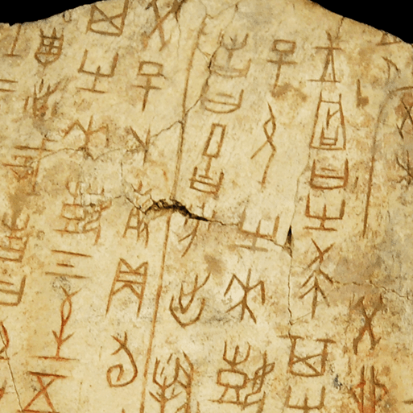

In Dynamic Dynasties, your child will learn about periods of ancient Chinese history. They will explore a timeline of the first five Chinese dynasties and learn about the legends surrounding the beginning of Chinese civilisation. They will take a deep dive into the history of the Bronze Age Shang Dynasty and explore evidence found in the ancient city of Yin. They will study oracle bones, learn about religious beliefs and explore bronze artefacts that set the Shang Dynasty apart from other civilisations. They will also study the hierarchy of the Shang Dynasty and discover who was powerful and who was powerless. They will look at warfare and find out how bronze technology gave the Shang Dynasty an advantage over their enemies. They will learn about the life of the great military leader, Fu Hao. To end the project, your child will find out how ancient China’s lasting legacy can be seen in the world today.