

**Maths**

Count, read, write and compare numbers to twenty.

Recognise one more and one less of numbers to 20.

Add and subtract numbers to 20.

Recite number bonds to 10.

Recognise 2D and 3D shapes.

**English**

Write simple sentences using full stops, capital letters and finger spaces.

Create a character description using adjectives.

Sequence sentences in the correct order using time connectives to write a recount.

**Curriculum Newsletter**

**Year 1 -Elm**

**Autumn**

|  |
| --- |
| **History – Childhood**  Use common words to relate to the passing of time.  Order information on a timeline.  Learn about changes within living memory. |
| **Geography – Our Wonderful World**  Identify seasonal and daily weather patterns in the UK and hot and cold areas of the world. |
| **RE**  Know and discuss people who are special to me.  Recall special occasions.  Know and discuss people who are special to me and discuss special occasions such as religious festivals.  Recall some Christian festivals and how they are celebrated. |
| **PSHE**  Classroom rules. To understand rules and why they are important. **My Happy Mind ‘Celebrate’.** To understand their Character and strengths and how to grow strengths. |
| **PE**  Master movements including running, jumping, throwing and catching, as well as developing balance, agility and co-ordination, and begin to apply these in a range of activities. |

|  |
| --- |
| **Science** – Everyday Materials & Human Senses  Identify and name a variety of everyday materials, including wood, plastic, glass, metal, water and rock.  Name, identify and label basic parts of the human body.  Recall the five senses and which body parts they are associated with. |
| **Art** – Mix it & Funny Faces and Fabulous Features  Identify and use paints in the primary and secondary colours.  Identify similarities and differences between two pieces of art work. |
| **Design Technology** – Shade and Shelter  Describe the similarities and differences between two products.  Create a design to meet simple design criteria.  Select and use a range of materials. |
| **Computing** – Logging on. Online Safety and Grouping  Know how to stay safe online and the SMART rules.  Sort items on a computer. |
| **Music**  Appreciating and listening to recorded music and use untuned instruments and voices. |

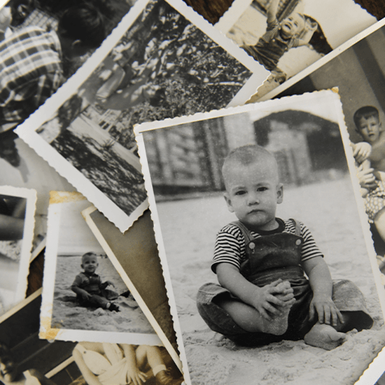

Other Information

PE days: Monday. Children will need to wear their PE kits to school on a Monday. Please ensure your child brings a named water bottle each day

**Theme: Childhood**

This project teaches children about everyday life and families today, including comparisons with childhood in the 1950s, using artefacts and a range of different sources.