**Charlottes Adventure**

Use this box to generate adjectives and modifying nouns to describe both Charlotte and the setting.

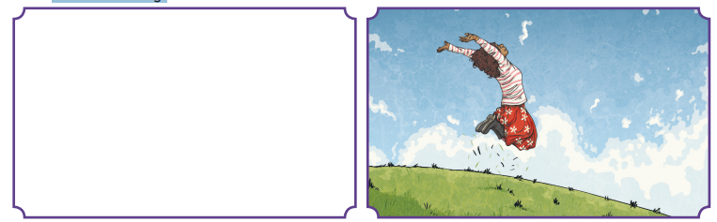

1. Use your amazing adjectives or modifying nouns to create expanded noun phrases:

A ______________________________________________girl jumped in a _________________________________________________________ field.

1. Next, use a fronted adverbial to give extra detail about the manner of the jump:

_____________________________________________________, a _______________________________________________ girl jumped in a ____________________________________________________ field

1. Finally, choose one of the following subordinating conjunctions:

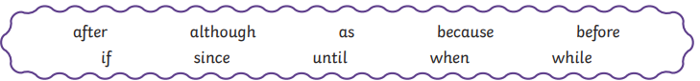

Complete your sentence by adding a subordinate clause beginning with a subordinating conjunction, which gives extra information about the reason she jumped.

____________________________________________________, a _______________________________________________ girl jumped in a _________________________________________________ field _________________________________________________________.