 | Autumn 1  (8 weeks) | Autumn 2  (7 weeks) | Spring 1  (6 weeks) | Spring 2  (5 weeks) | Summer 1  (7 weeks) | Summer 2  (6 weeks)
Cross-curricular theme | Ourselves and our community   | Let’s Celebrate   | The Monarchy   | Down at the Bottom of the Garden  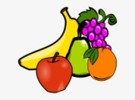 | Brilliant Beasts  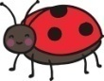  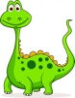 | Happy Holidays!  
Predictable interests | Autumn  Harvest  Spooky | Bonfire night  Remembrance  Diwali  Christmas | Winter  Chinese New Year  Valentine’s day  Shrove Tuesday | Spring  Easter  Mother’s Day  World Book Day | Early summer | Summer  King’s Birthday  Father’s Day
Experiences/Visits and Visitors | Walk to local shops  Visitors- fire fighters/police/parent who is a paramedic.  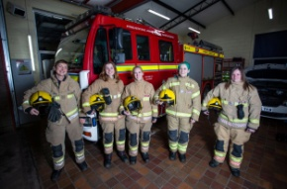  Parent Link- Love reading afternoon | Owl Sanctuary  Church visit to St Aidan’s Church.  Church Visit to the Valey Café – Hot Chocolate  Post a letter to Father Christmas at the Post office  Parent Link- Make Christmas party hats   | Parent Link- Chinese New Year Assembly.  Maths Parents Afternoon  Children to write a letter to the King | Visitors- Gym instructor  School nurse  Visit to Morrisons- healthy eating  Parent Link- Mother’s Day   | Visitor- Creepy Crawly roadshow  Watch Superworm at the Vue Lancaster  Visit to Williamson’s Park- minibeasts and butterflies  Grow stick insects  Make wormery  Snails to explore  Butterfly enclosure  Parent Link- outdoor learning- planting, minibeast hunt  EYFS Day - AXIA | Visit the beach- make sandcastles and eat ice creams  Parent Link- end of year picnic, eat ice creams on the field with children and families  
Characteristics of effective teaching and learning  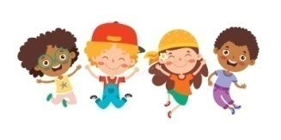 | Playing and Exploring  Active learning  Creating and thinking critically  All aspects weave through all areas of learning throughout this half term | Playing and Exploring  Active learning  Creating and thinking critically  All aspects weave through all areas of learning throughout this half term | Playing and Exploring  Active learning  Creating and thinking critically  All aspects weave through all areas of learning throughout this half term | Playing and Exploring  Active learning  Creating and thinking critically  All aspects weave through all areas of learning throughout this half term | Playing and Exploring  Active learning  Creating and thinking critically  All aspects weave through all areas of learning throughout this half term | Playing and Exploring  Active learning  Creating and thinking critically  All aspects weave through all areas of learning throughout this half term
Communication and language | Good sitting and listening rules  Enjoy a story.  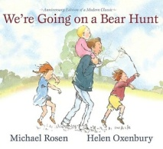  Learn and use a wide range of vocabulary.  Follow a 2 part instruction.  Understand why questions.  Sing a large repertoire of songs and rhymes.  Engage with non-fiction text. | Pay attention to more than one thing at a time.  Learn and use a wide range of vocabulary.  Sing a large repertoire of songs and rhymes.  Start a conversation with an adult or friend.  Engage with non-fiction text. | Listen to a story and recall key points.  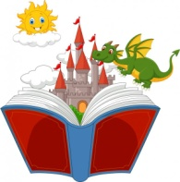  Learn and use a wide range of vocabulary.  Answer a 2 part question.  Sing a large repertoire of songs and rhymes.  Talk about familiar books.  Engage with non-fiction text. | Learn and use a wide range of vocabulary.  Sing a large repertoire of songs and rhymes.  Ask questions to find out more and clarify understanding.  Familiarity and understanding about stories.  Engage with non-fiction text. | Learn and use a wide range of vocabulary.  Sing a large repertoire of songs and rhymes.  Talk to organise play.  Speak in well formed sentences.  Describe events in detail.  Explain how things work and why they might happen.  Deep familiarity and retell story.  Engage with non-fiction text. | Learn and use a wide range of vocabulary.  Sing a large repertoire of songs and rhymes.  Connect ideas using connectives.  Engage with non-fiction text.  
Personal, social and emotional development | Class rules and expectations  Sharing and taking turns  Making new relationships  Independently use resources in provision to achieve a goal.  Able to leave their adult.  Able to say if they are happy or sad.    Managing own needs.  The Colour Monster story- feelings  PRSHE scheme | Class rules and expectations and moderate behaviour accordingly.  Sharing and taking turns  Making new relationships  PRSHE scheme | Rules and why we have to follow them  See themselves as a valuable individual.  PRSHE scheme | Caring for others/animals/plants/pets/family members  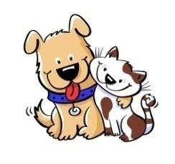  Build respectful relationships.  PRSHE scheme | Caring for creatures, looking after Minibeasts.  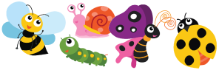  Talking about being scared and taking risks.  Express feelings of self and others.  Resilience and perseverance in face of challenge.  PRSHE scheme | Kidsafe week    Trying something new, keeping safe at the seaside , use of suncream.  Road safety training  PRSHE scheme
Physical Development | PE unit  Lancashire PE Scheme of Work 2020- Themes  ‘Welcome to PE’  Progression 1-6  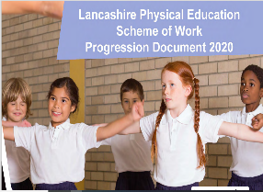  Transport Theme  Progression 1 &2  Dough disco  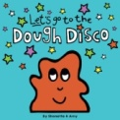  Large muscle movements.  One handed tools and equipment. (Loop scissors)  Starting to independently use a knife and fork.  Preference for a dominant hand.  Increasing independent meeting own care needs.  Core muscle strength when sitting on floor or table.  Develop skills to manage school day. | PE Unit  Lancashire PE scheme of work 2020 – stories  ‘How to Catch a Star by Oliver Jeffers’  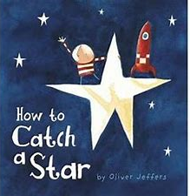  Progression 1-5  Introduce Squiggle whilst you wiggle  Teach Mr.Crocodile and begin to have control of pencil.  Increasingly independent getting dressed and undressed. | PE Unit  Lancashire PE Scheme of Work 2020- Themes  ‘Castles’  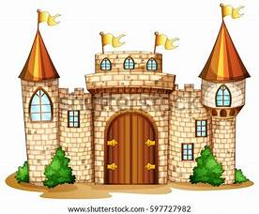  Progression 1-5  The Queens Hat by Steve Antony- children to move like to soldiers in the book- dangle/march/clambered/bolted/dashed......  Comfortable grip and good control of pencil.  Able to use regular scissors. | PE Unit  Lancashire PE scheme of work 2020 – stories  ‘Jack and the Beanstalk’  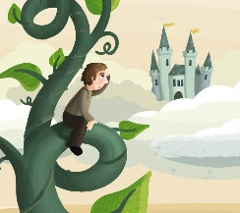  Progression 1-5  Making healthy choices about food, drink, activity and tooth brushing.  Know about factors that affect health and well-being.  Confidently use pencils for drawing and writing, paintbrushes, scissors, knives, forks and spoons. | PE Unit  Lancashire PE Scheme of Work 2020- Themes  ‘Minibeasts’  Progression 1-6  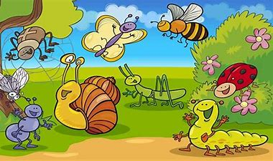  Develop a fast and efficient hand writing style. | PE Unit  Lancashire PE Scheme of Work 2020- Themes  ‘Seaside’  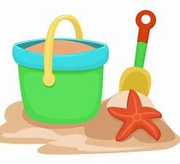  Progression 1-5’
Key books and Texts | Skill- narrative  The three Little Pigs and variations- The true story of the three little pigs/ The big bad pig and the three little wolves.  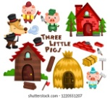  Additional texts/ryhmes  You Choose- Houses page  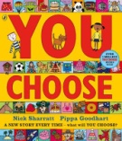  Non-fiction Homes around the world.  Traditional tale- The three Billy Goats Gruff- farm animals- Farm in provision  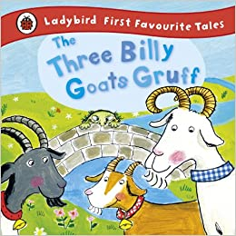  Rhymes linked to Ourselves- Head, Shoulders, knees and toes.  If you happy and you know it.  Nursery rhymes  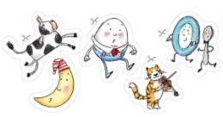 | Skill- posters/instructions  Goldilocks  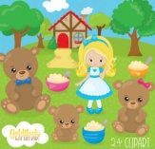  Owl babies  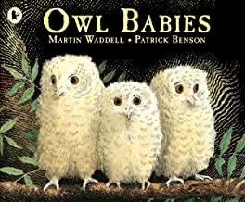  Kipper’s Birthday- The Toys Party (make cake from the book)  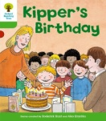  Write instructions  Nocturnal animals-  Peace at Last  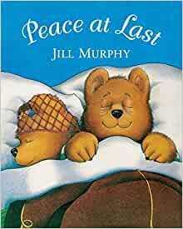  Rhymes-  Poetry Basket The Wise Old owl  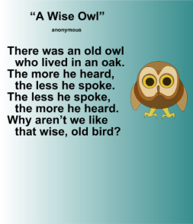 | Skill- lists  The Queens Hat  By Steve Antony  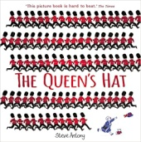  Royal Dinner by Brenda Parks  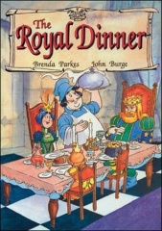  Kings and Queens books  Cinderella/Princes and Princesses  The Queens Knickers  The Royal Nappy  Rhyme: Sing a song of sixpence  The Queen of hearts- performing- link to Valentines  Poetry Basket:  I can build a snowman  Carrot Nose | Skill-recipe/innovation of Evil pea character  Oliver’s Fruit salad  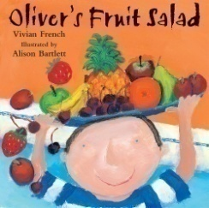  Supertato series  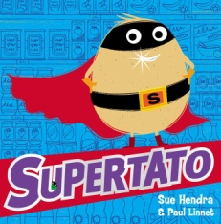  Poetry Basket:  Pancakes by Christina Rossetti  Non fiction book o growing and planting  Healthy eating books- link here with visit to the Doctor/Dentist- refer back to Aut 1- People who help us.  Topsy and Tim books  Jasper’s Beanstalk  The Tiny Seed  The very hungry caterpillar  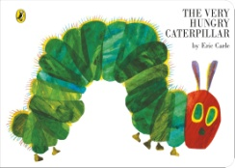 | Skill-reporters video  Mad about Minibeasts  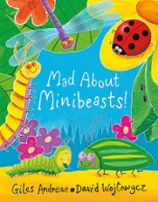  Snail, snaily snails by Bonnie Bader  Why do we need Bees?  Usborne Beginners Nature 10 book set  Spider series of 10 books to buy (£15 Amazon)  Bees and Wasps by James Mc Lean  Spinderella  Non fiction minibeast texts  The bad tempered ladybird  Snail Trail  Norman the Slug with the silly shell  Superworm  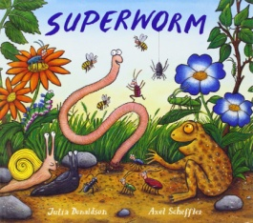  The very quiet cricket  What the ladybird heard  Bug Hotel- Clover robin book of nature. | Skill- narrative, writing own story  Handa’s Surprise  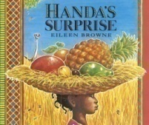  Billy Bucket by Nick Sharratt  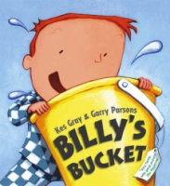  What the ladybird heard goes on holiday  What the ladybird heard at the seaside  Boris goes camping  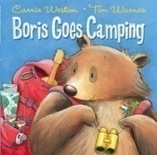  Seaside range of poems  Stories from around the world pack of 10 TES  Lighthouse keepers lunch and picnic.  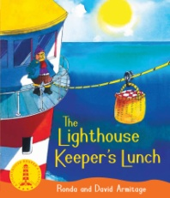
Key vocabulary | Label, sentence, caption  Non fiction  roof, window, door, house types-detached, semi, terraced, bungalow, flat, caravan, materials- glass, bricks ,slate, plastic, metal, cement, wood.  Rhyme | Celebration/decorate/mix/pour/bake  recipe/ingredients  beginning/middle/end  nocturnal/dark/exhausted/late  wise/Oak/less/more | Country, regal, landmark.  Baked, ingredients, recipe  clambered, bolted, dashed, squeezed, floated,  dangled | Juicy,spikey,smooth  Instructions, first, then, next last  Superhero,evil, horrid,mean,unpleasant  Easter, cross, Jesus
Performance | Harvest Service Performance | Nativity Play for the whole school and parents | Perform the National anthem | Easter Service – Palm Sunday. | Minibeast moves/rhymes Assembly for Ks1 children | Summer performance for parents
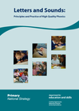  Phonics | Phase 1 including a heavy focus on oral blending and segmenting aspect 7.  Phase2 GPC’s | Tricky words I/no/to/go/the/into  Reading and writing ph2 GPC’s in words and sentences. | Introduction of Phase 3 GPc’s  Tricky words he/she/was/my/we/be/me/all/they  Drip Phase 4 in Phase 2 and 3 where appropriate | Continuation of Phase 3 GPC’s  Reinforcement of Ph 3 tricky words  Drip Phase 4 in Phase 2 and 3 where appropriate | Further application of phase 3 GPc’s in words and sentences  Drip Phase 4 in Phase 2 and 3 where appropriate | Phase 4 and application of phase 3 sounds  Drip Phase 4 in Phase 2 and 3 where appropriate
Reading   | Introduce home-school readers.  Purple band books- no words  Pink band books and satpin reading games and activities | Pink band reading books  Read individual letters by saying the sounds.  Blend sounds in to words.  Ch. re-read books to build up confidence in word reading. | Red band reading books  Read some digraphs and tricky words (P3) | Yellow band reading books  Engage in extended conversations about stories. | Yellow/blue band reading books | Blue/green band reading books
Writing | Step 1  Use artists work Bridget Riley, Kandinsky.Paul Klee to explore line  Making marks, wavy, zig zag, straight, curved.  Links to gross motor and fine motor activities.  1.Print has meaning.  3. Read from left to right and top to bottom.  Develop phonological awareness.  Recognising name | Step 2  More focus on Letter formation and recognition  Name writing activities  Step 3: Segment VC and spell tricky words  Use some print and letter knowledge in early writing.  Write some or all of their name.  Write some letters accurately.  Phonetically plausible attempts at spelling word using phoneme fingers.  Read p2 tricky words. | Step 4: CVC words  2. Understand that print can have different purposes.  5. Page sequencing (links to ind.writing) | Step 5 W: Writing I can see/It is a sentences. Dictated  4. Understand different parts of a book. | Step 6:  Phase 2 and 3 sentences and variations more independently.  Write short sentences using green capital letter and red full stop. Use sentence checklist and mantra.  Re-read to check it makes sense. | Step 7:  Sentence writing  Story writing-  Form lowercase and capital letters correctly.
Maths  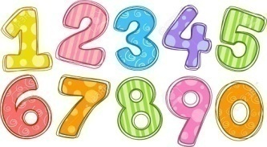 | Key learning introduced through Numberland:  Rote counting  Counting objects  Shape | Key learning introduced through Numberland:  Number sense  Number recognition  Number graphics  Calculating | LAPS Spring term  Counting and comparing  Partitioning and understanding part-whole  Understand teen numbers  Distance- length, height,width  Opportunity to apply number 20  Mass, weight, capacity,volume  Shape and sorting | LAPS Spring term  Addition  Subtraction  Halving and doubling  Number sense  Addition and subtraction x2 weeks | LAPS Summer term  Counting, comparing and ordering  Whole addition and subtraction  Fractions  Distance- length, height,width,weight  Capacity- volume and money  Shape and sorting | LAPS Summer term  Time  Space  Money and sorting  Number sense  Addition and subtraction  Addition and subtraction
Understanding the world | HUMANS – SCIENCE  MATERIALS - SCIENCE  MAPPING - GEOGRAPHY  SEASONAL CHANGES – AUTUMN - SPRING  Materials- hair dryer experiment and/or water proof roof.  Name different body parts and the colour of us  To know about our community and where we live - Bamber Bridge  Types of houses and features of houses.  Use all our senses to explore natural materials. (outdoor learning)  Begin to make sense of own life story.  Changes they notice.  Developing positive attitudes about the differences between people.  Talk about family and familiar adults.  Draw information from a map  Autumn learning | LIGHTS AND SHADOWS – SCIENCE  EARTH AND SPACE – SCIENCE  SEASONAL CHANGES – WINTER - SPRING  Diwali  Story of Rama and Sita  Guy Fawkes- Historical figure – marshmallows and firepit  Light and dark experiment/shadow puppets?  Baking – coconut burfi  Use all our senses to explore natural materials. (outdoor learning  Changes they notice. | SOUND – SCIENCE  OUTDOOR AND ADVENTURE -GEOGRAPHY  Simple family tree- son/grandchild/great grandchild  Making links between family members  Baking –pancakes  Use all our senses to explore natural materials. (outdoor learning  Begin to make sense of own life story.  Changes they notice.  Developing positive attitudes about the differences between people.  Bamber Bridge place in the World/London/UK.  Compare historical figures the Queen  Similarities/differences between life here and other countries. Bamber Bridge-London | SEASONAL CHANGES – SPRING SCIENCE  PEEK INTO THE PAST - HISTORY  Fruit and vegetable tasting  Make fruit kebabs  Labelling different parts of the plant  School Plant Pots - plant fruit and vegetables.  Interest in different occupations.  Plant seeds and care for growing things.  Changes they notice. | LIVING THINGS AND THEIR HABITATS – SCIENCE  ANIMALS EXCLUDING HUMANS – SCIENCE  AROUND THE WORLD – GEOGRAPHY  Grow your own  Caterpillars  Stick insects  Tadpoles  Snails  Wormery  Shadow drawing with dinosaurs etc.  Easy scope- ICT  Changes they notice.  Summer learning seasons | SEASONAL CHANGES - SUMMER – SCIENCE  ADVENTURE THROUGH TIME - HISTORY  Packing to go on tour holidays- make lists  What would you find in a rock pool compared to a pond  Sandcastles  Ice creams  Ice cream role play  Kiddilk the Frog- BBC Bitesize, links to droughts and other climates  Weather links  Changes they notice.  Forces – floating?  Developing positive attitudes about the differences between people.  Talk about different countries.  Nelson Mandela?  Similarities/differences between life here and other countries.
RE | EYFS 1  Why are we all different and special?  EYFS 2  Why do Christians say thank you to God at Harvest Time?  EYFS 3  How do Christians celebrate Jesus’ birthday? |  | EYFS 7  Special People  EYFS 5  Why did Jesus tell stories?  EYFS 6  Why did Christians believe that Easter is all about love? |  | EYFS 9  Where do some people go to worship God?  EYFS 11  Why do people of faith have times of special celebrations?
Expressive arts and design | SELF – REGULATION: MY FEELINGS PRSHE.  LET’S GET CRAFTY – DT  COMPUTING SYSTEMS AND NETWORKS - COMPUTING  Learn to sing nursery rhymes and action songs.  Portrait  Singing - head and shoulders, knees and toes.  Nursery rhymes.  Draw round teacher/ta and label, colour in etc.  Explore different materials freely.  Develop own ideas and decide which materials to use to express them.  Join different materials to make our own houses and homes.  Mondrian – closed lines  Listen with increased attention to sounds – p1 phonics  Play instruments with control and express feelings. | BUILDING RELATIONSHIPS; SPECIAL RELATIONSHIPS  SEASONAL PROJECTS – DT  Learn to sing more nursery rhymes and action songs.  Make a chair for Baby bear- structures- DT  Christmas crafts – include a skill in the making.  Mixing colours to make fireworks.  Rangoli patterns  Diwali music  Christingle  Nursery rhymes and songs.  Cha cha slide/party action songs. – link xmas party  Andy Goldsworth- Autumn Walk  Explorify- Autumn  Create collaborative art | SELF REGULATION: LISTENING AND FOLLOWING INSTRUCTIONS.  EXPLORING SOUND – MUSIC  JUNK MODELLING- DT  Learn to sing more nursery rhymes and action songs.  Make Union Jack flags  How to paint/draw your own royal portrait- Make a royal gallery using different media each day- watercolours  Look at different portraits- and different family members  Nursery rhymes and songs.  Ipads- how to take a quality picture.  Look and old pictures of Morecambe and compare to today.  National anthem.  Complex stories using small world.  Make imaginative and complex small worlds.  Innovate nursery rhymes and songs  Play instruments with control and express feelings – nature walk | Managing self: TAKING ON CHALLENGES PRSHE  MUSIC AND MOVEMENT – MUSIC  DRAWING MARVELLOUS MARKS - ART  Learn to sing more nursery rhymes and action songs.  Paint/exploration using vegetables.  Observational drawings of fruit and vegetables using different media.  Van Gough – sunflowers  Nursery rhymes and songs. | BUILDING RELATIONSHIPS; MY FAMILY AND FRIENDS  PRSHE  PAINTING AND MIXED MEDIA - ART  Create your own pet minibeast with made up features from lots of different minibeasts. Add other materials.  Workshop- hand print spiders.  Busy fingers- creating webs out of paper plates and wool.  Nursery rhymes and songs.  Innovate nursery rhymes and songs  Play instruments with control and express feelings – nature walk  Collaborative art project where we edit and refine  Matisse snail art | MANAGING SELF – MY WELLBEING  PRSHE  BIG BAND - MUSIC  BOOKMARKS - DT  Design their own lighthouse using different materials.  Make and evaluate it.  Aboriginal art??  African music?  Nursery rhymes and songs.  African instruments  Summer performance – bringing all ideas. African songs/instruments/artwork.  Parents in.  Sculpture- landmarks made out of clay

