

Thursday 1st October 2026

Dear Parents /Carers,

Upper Key Stage 2 Leadership Training

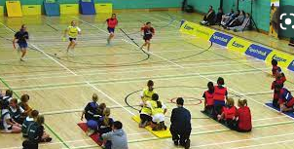

Your child has been chosen to represent school as a sports leader at a Leadership Training event which has been organised by Stockport SHAPES Alliance.

The event takes place on Wednesday 7th October 2026 at Aquinas, between 9:30am and 11:30am.

The children will be walking to Aquinas College with staff on a route which has been risk assessed by staff.

The children must wear their PE kits for the whole day on Tuesday. They may bring a bottle of water and a small, healthy snack with them for the visit.

If you have any queries please do not hesitate to contact admin@calegreen.stockport.sch.uk

Yours sincerely,

Mrs A Ajaz

PE Subject Leader

