Monday 12th October 2026

Dear Parents / Carers,

BBC 500 Words Competition
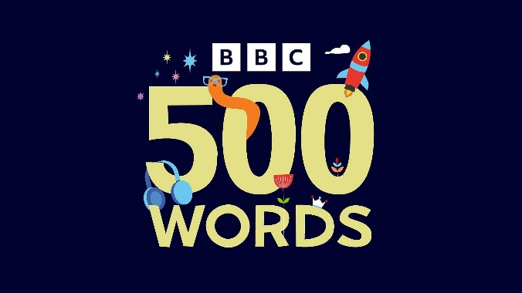

As part of our Story Writing club, pupils have been working hard on crafting their own creative stories. We would love to give them the opportunity to enter their stories into this year’s BBC 500 Words competition!

The BBC 500 Words competition is the UK's biggest children's story-writing competition for 5-11-year-olds. It is currently open for entries and closes at 9:00pm on Friday 6th November 2026.

To enter your child's story, we require consent from parents/guardians.
Please note the following key details:

- Entries must be an original piece of fiction under 500 words.
- Submissions are handled in accordance with the BBC’s competition rules and privacy policy.
- More information about the competition can be found at: https://www.bbc.co.uk/teach/500-words

If you are happy for your child’s story to be submitted and they are keen to enter, please give permission on school spider.

Thank you for supporting our young writers!

If you have any questions please contact school admin@calegreen.stockport.sch.uk

Yours sincerely,

Mrs Powell-Gill

