Monday 28th September 2026

Dear Parents /Carers,

Key Stage 2 Kurling and Boccia
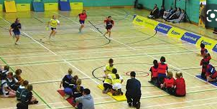

Your child has been chosen to represent school at a Kurling and Boccia event
which has been organised by Stockport SHAPES Alliance.

The event takes place on Tuesday 6th October 2026 from 10am till 11:30am at Aquinas. Children will leave school at 9:40 and return to school by 12pm.

The children will be walking to Aquinas with staff from school on a route which has been risk assessed.

The children should wear their PE kits for the whole day on Tuesday. They may bring a bottle of water and a small, healthy snack with them for the visit.

If you have any queries please do not hesitate to contact admin@calegreen.stockport.sch.uk

Yours sincerely,

Miss A Ajaz and Mrs Lewis

PE Subject Leaders

