
Monday 30th November 2020
Dear Parents/ Carers,

Christmas Activities

It’s that time of year again (‘oh yes it is!’) and whilst things may be a little different this year we are more than ever determined that the children will have a wonderful and magical time in school.

Please find detailed below some of the dates for activities which we are planning:

Cale Green Christmas Raffle – Friday 18th December
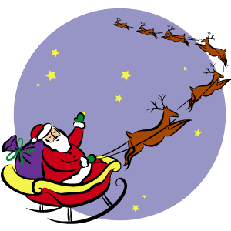

The ‘Friends of Cale Green’ (FROGs) and members of staff have once again kindly donated prizes for our annual Christmas raffle to raise much needed funds for school.

Tickets are priced at £1.00 for a strip or £5.00 for 6 strips and will be on sale from Monday 30th November.

This year, there will be only be 1 way tickets can be purchased - children must bring in the correct money in a sealed envelope (no change will be given).

The draw will take place during the Family Assembly on Friday18th December.

Christmas Dinner and Jumper Day - Friday 11th December

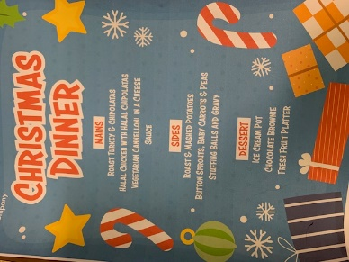

If your child normally has a packed lunch and would like a Christmas dinner, then please follow the link and pay for the dinner using Parent Pay. The cost of the dinner is £2.20.

The closing date for ordering a dinner is Friday 4th December.

Children who normally have a school dinner will be provided with a Christmas dinner on that day – sprouts and all!


On Friday 11th December will have our annual Christmas Jumper and Christmas dinner day. Children are invited into school in their most festive jumpers or sweatshirts for a small donation to Fareshare.



https://fareshare.org.uk/donate/

FareShare is the UK’s national network of charitable food redistributors, made up of 17 independent organisations. They take good quality food from right across the food industry and get it to almost 11,000 frontline charities and community groups.

Christmas Shows / Activity Dates

This year there will be a special film of the children performing Christmas songs and retelling the story of The Nativity. The film will be shown to parents on Friday 18th December during one of our special Christmas assemblies.
The children will also be getting, through the magic of the internet, a special visit and story from Father Christmas, an online panto, Christmas Story Time, Animoto and lots of other delightful bits and bobs!

The main dates and activities are:

Wednesday 10th December: ‘Can do Christmas’ performance – children only
Friday 11th December: Christmas Dinner and Christmas Jumper Day – children only

Tuesday 15th December: Father Christmas visit to the Nursery (Mrs. Adie’s class) – children only
Wednesday 16th December: Father Christmas visit to Key Stage 1 – children only
Wednesday 16th December: Father Christmas visit to Lower Key Stage 2 – children only
Thursday 17th December: Father Christmas visit to Reception / Nursery (Mrs. Knox’s class) – children only
Thursday 17th December: Father Christmas visit to Upper Key Stage 2 – children only
Thursday 17th December: Father Christmas will be reading ‘The Little Christmas Tree’ – children only
Friday 18th December 1.30pm: The Nativity and class Christmas carols / Christmas Raffle and our Christmas film / Animoto– online invitation to parents / families

Monday 21st December 2.000pm: Christmas Story Time – online invitation to children / parents / families
Tuesday 22nd December 1.30pm: Christmas Assembly, carols and some special little surprises! – online invitation to children / parents / families

Christmas Cards and Presents



This year we are asking you not to send cards and gifts into school. Instead, the staff have asked that if anyone makes a donation to our justgiving page then any money raised will be used to support children and families in our community:

The December Newsletter will be published later this week.

Yours sincerely,

Mr. D. Marshall



