 | Theme 1 | Theme 2 | Theme 3 | Theme 4
1DECISION UNITS  THEMES / FOCUS WEEKS  LINKS TO UNRC ARTICLES | Keeping Healthy and Safe / Being responsible  (PSHE week- week 1 Parliament week November)  Article 28 and 29 Right to and goals of Education.  Article 7 Right to name, Nationality  Article 8 Identity  Article 24 Health and Health services  Article 14 Freedom of thought  Article 33 Drug abuse | Keeping Healthy and Safe / Being responsible  (PSHE week- week 1 Parliament week November)  Article 12 Respect the views of the child  Article 30 minority groups  Article 14 Freedom of thought  Article 38 War and conflict  Article 33 Drug abuse | Relationships / A World without judgement (Internet-Safety Week / Children’s Mental Health Week)  Article 17 Access to Media  Article 12 Respect the views of the child  Article 14 Freedom of thought  Article 24 Health and Health services | Our World / Fire Safety  Moving on  Article 24 Health and Health services
RSE Taught in a combination of composite classes and single year - group lessons as appropriate to age and stage of learning.
1DECISION  (Year Five)  CELEBRATING DIFFERENCE | .  1.Peer Pressure  s  Identifying / managing peer pressure split into 2 lessons  2.Peer Pressure  Extension Being  safe – Simply  RSHE  Assessing risk  3.Looking Out for  Others  Adults’ &  Children’s Views  4.Looking Out for Others Extension General wellbeing – Simply RSHE | 1.Anger  Adults’ & Children’s  Views  2.Anger Extension General wellbeing – Simply RSHE  3.Smoking  Adults’ & Children’s Views  4.Smoking Extension  Drugs, Alcohol, Tobacco & Vaping – Simply RSHE | 1.Puberty  Adults’ and Children’s Views  2.Puberty Extension Developing bodies – Simply RSHE  3.Inclusion & Acceptance  Adults’ & Children’s Views  4.Inclusion & Acceptance Extension  Families & people who care for me - Simply RSHE | 1.Enterprise  Adults’ & Children’s Views  2.Enterprise Extension NO Simply RSHE Links  3.First Aid Year 5  First Aid Year 5 (Part 1)  4.First Aid Year 5 Extension Basic first aid – Simply RSHE
CELEBRATING DIFFERENCE | 1.LGBT+  Activity 4: Diverse nature of families +  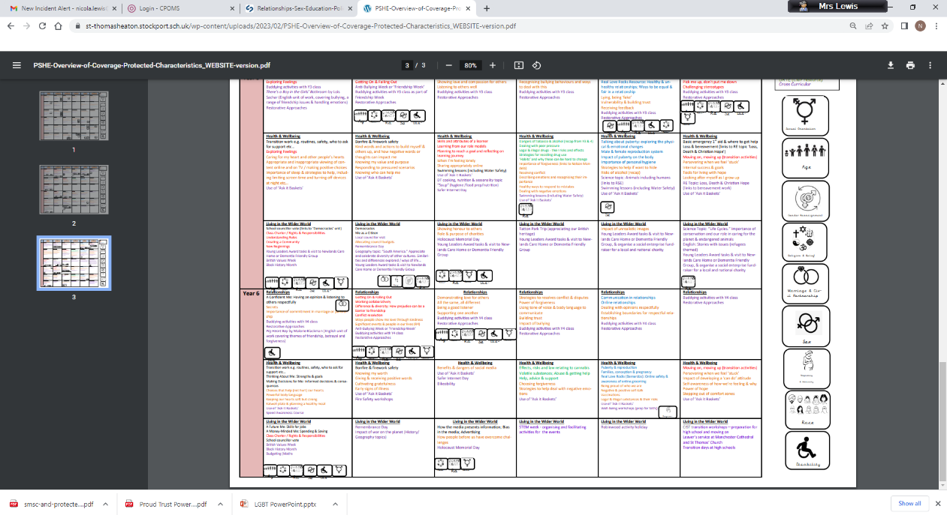  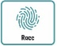  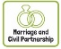  Stonewall Book The Great Big Book of Families.  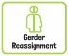  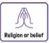  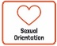 | 1.LGBT+  Rainbow resource – KS2 Music Film Scores.  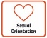 | 1.LGBT+  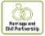  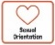  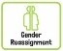  Y5 / 6 Proud Trust – King and King Play LGBT – 2 x 1hour lessons.  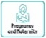
LIVING IN THE WIDER WORLD  MODERN BRITISH VALUES  SCHOOL VALUES  TRANSITION  FINANCIAL CAPABILITY  Circle times | 1.Class Charter Rights and Responsibilities  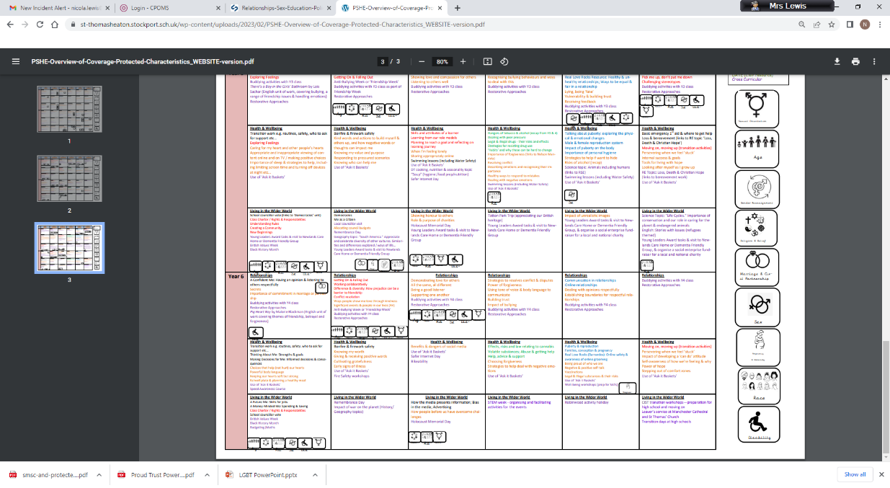  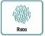  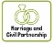  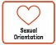  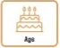  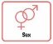  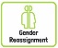  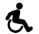  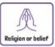  Mutual respect  2.Setting ground rules; Cale green Code; Class Vision Statement; In this class we speak poster. School council election speeches | 1.FINANCIAL: Natwest resources – How Can I keep my money safe?  2.Black History Month  Remembrance Day Visit to cenotaph  3.Democracy / The Rule of Law.  Links to Parliament week.  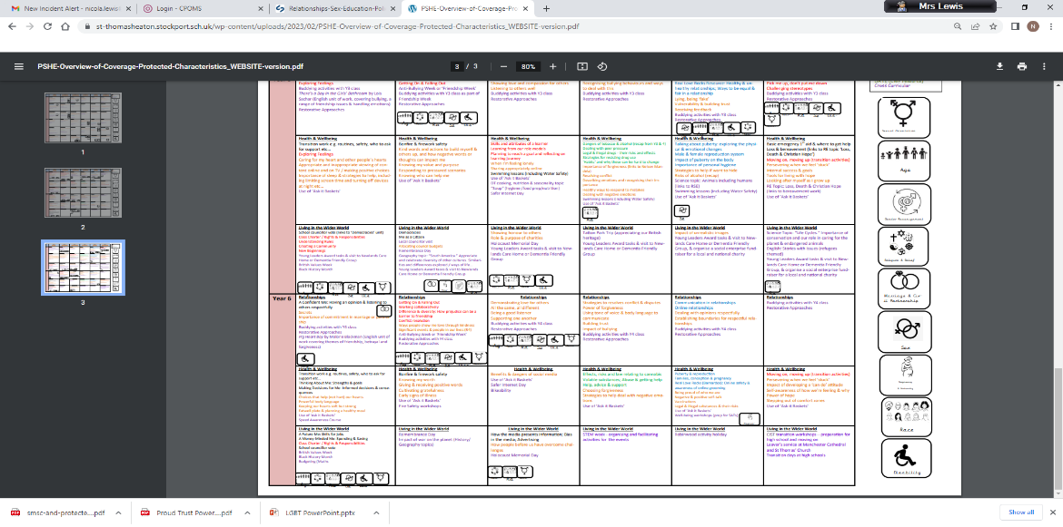  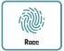 | 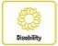  1.Children’s Mental Health Week  Individual Liberty / Tolerance of those with different faiths and beliefs.  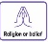  Science week / STEM activities linked to wider world of work  2.FINANCIAL - Natwest resources – What affects my choices about money? | 1.Careers fair / aspirations week / World of work day Cv’s / interview skills.  2.Year 6:10 week Chameleon Project; care wheel; school questionnaire; transition day.  Moving on; Growing up. Transition to next class.  (Year 6 Chameleon Project)  Y6 Residential holiday
Whole School Activities | Special Friends table  Play Leaders  Water Safety Swimming  Visit From GMP  Bonfire Night Safety  Fire Safety  Restorative approaches  Ask-it baskets  Water safety lesson using materials from Canals and Waterways Trust  Unicef Rights Respect school – Steering stars  Article of the month  Bikeability Being a safe cyclist (Cycling Proficiency and road safety

