 | Theme 1 | Theme 2 | Theme 3 | Theme 4
1DECISION UNITS  THEMES / FOCUS WEEKS  LINKS TO UNRC ARTICLES | Keeping Healthy and Safe / Being responsible  (PSHE week- week 1 Parliament week November)  Article 28 and 29 Right to and goals of Education.  Article 7 Right to name, Nationality  Article 8 Identity  Article 24 Health and Health services Article 38 War and armed conflict  Article 14 Freedom of thought | Feelings and Emotions / Keeping / Staying safe  (Anti-bullying week / Road Safety week)  Article 24 Health and Health services  Article 12 Respect the views of the child  Article 30 minority groups  Article 14 Freedom of thought  Article 33 Drug abuse | Relationships / A World without judgement (Internet-Safety Week / Children’s Mental Health Week)  Article 17 Access to Media  Article 12 Respect the views of the child  Article 14 Freedom of thought | Our World / Fire Safety  Moving on  Article 24 Health and Health services
RSE Taught in a combination of composite classes and single year - group lessons as appropriate to age and stage of learning.
1DECISION  (Year Three) | 1.Leaning Out of Windows  What I’ve Learnt  2.Leaning Out of Windows Extension Personal safety – Simply RSHE  3.Stealing  What I’ve Learnt  4.Stealing Extension NO Simply RSHE Links | 1.Grief  What I’ve Learnt  2.Grief Extension  General wellbeing – Simply RSHE  3.Medicine  What I’ve Learnt  4.Medicine Extension  Drugs, Alcohol, Tobacco & Vaping – Simply RSHE | 1.Touch  What I’ve Learnt  2.Touch Extension Being safe – Simply RHSE RSHE  3.Tolerance  What I’ve Learnt  4.Tolerance Extension  Respectful, kind relationships - Simply RSHE | 1,Looking After Our World  What I’ve Learnt  2.Looking After Our World Extension NO Simply RSHE Links  3.Enya & Deedee Visit the Fire St.  What I’ve Learnt  4.Enya & Deedee Visit the Fire St. Extension Personal safety - Simply RSHE
CELEBRATING DIFFERENCE | 1.LGBT+  Stonewall Booklist My Footprints by Bao Phi and Basia Tran  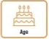  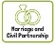  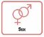  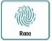  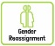  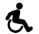  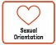 |  |  | 1.LGBT+  Rainbow classroom / Proud Trust – Incorrect / correct vocabulary and meanings. Discussion about how we should use the word ‘gay’.  2.Rainbow Classroom – KS2 Symbols and their meaning.
LIVING IN THE WIDER WORLD  MODERN BRITISH VALUES  SCHOOL VALUES  TRANSITION  FINANCIAL CAPABILITY  Circle times | 1.Class Charter Rights and Responsibilities  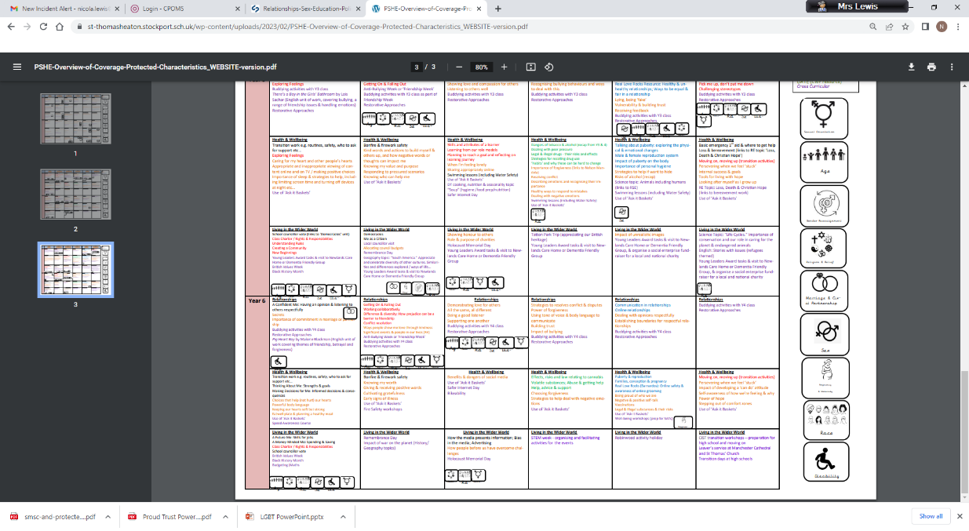  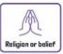  Mutual Respect  2.Setting ground rules; Cale green Code; Class Vision Statement; In this class we speak poster. School council election speeches | 1.Black History Month  2.Remembrance Day Visit to cenotaph  3.Democracy / The Rule of Law.  Links to Parliament week.  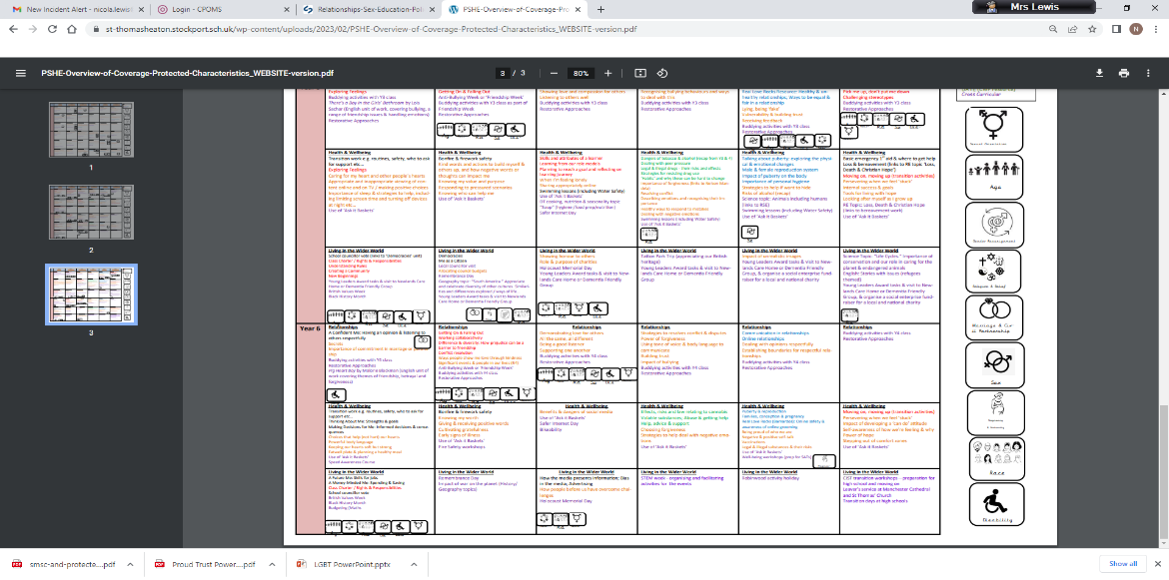  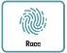 | 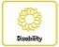  Individual Liberty / Tolerance of those with different faiths and beliefs.  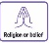  Science week / STEM activities linked to wider world of work  2.FINANCIAL: Natwest resources – How Can I use a Bank Account? | 1.FINANCIAL: Natwest resources – Enterprise: Raising Money For Charity – *Links to Unicef Global Goals and or helping local communities etc
Whole School Activities | Special Friends table  Play Leaders  Water Safety Swimming  Visit From GMP  Bonfire Night Safety  Fire Safety  Restorative approaches  Ask-it baskets  Water safety lesson using materials from Canals and Waterways Trust  Unicef Rights Respect school – Steering stars  Article of the month

